TARPORLEY CE
PRIMARY SCHOOL
Let Your Light Shine (Matthew 5)
Tarporley Church of England Primary School is a welcoming and friendly Church school that provides high quality education for children aged 5-11. As a Church school we hold our Christian Values at the heart of everything we do. These are: LOVE, FRIENDSHIP, TRUST, HOPE, FORGIVENESS, JOY & CELEBRATION

It is very important to us that the children are happy and experience the best education possible. We value strong links and a close partnership between home, church and school and recognise the importance of trust and shared responsibility in education.

Supporting pupils with medical conditions policy

Contents
1. Aims 3
2. Legislation and statutory responsibilities 3
3. Roles and responsibilities 4
4. Equal opportunities 5
5. Being notified that a child has a medical condition 5
6. Individual healthcare plans 5
7. Managing medicines 6
8. Emergency procedures 7
9. Training 7
10. Record keeping 8
11. Liability and indemnity 8
12. Complaints 8
13. Monitoring arrangements 8
14. Links to other policies 8
15. Appendix 1…………………………………………………………………………………………………………….9

1. Aims
This policy aims to ensure that:
- Pupils, staff and parents understand how our school will support pupils with medical conditions
- Pupils with medical conditions are properly supported to allow them to access the same education as other pupils, including school trips and sporting activities
The governing board will implement this policy by:
- Making sure sufficient staff are suitably trained
- Making staff aware of pupil’s condition, where appropriate
- Making sure there are cover arrangements to ensure someone is always available to support pupils with medical conditions
- Providing supply teachers with appropriate information about the policy and relevant pupils
- Developing and monitoring individual healthcare plans (IHPs)
The named person with responsibility for implementing this policy is the Headteacher Kerry Forrester

2. Legislation and statutory responsibilities
This policy meets the requirements under Section 100 of the Children and Families Act 2014, which places a duty on governing boards to make arrangements for supporting pupils at their school with medical conditions.
It is also based on the Department for Education’s statutory guidance: Supporting pupils at school with medical conditions.

3. Roles and responsibilities
3.1 The governing board
The governing board has ultimate responsibility to make arrangements to support pupils with medical conditions. The governing board will ensure that sufficient staff have received suitable training and are competent before they are responsible for supporting children with medical conditions.
3.2 The headteacher
The headteacher will:
- Make sure all staff are aware of this policy and understand their role in its implementation
- Ensure that there is enough trained staff available to implement this policy and deliver against all individual healthcare plans (IHPs), including in contingency and emergency situations
- Take overall responsibility for the development of IHPs
- Make sure that school staff are appropriately insured and aware that they are insured to support pupils in this way
- Contact the school nursing service in the case of any pupil who has a medical condition that may require support at school, but who has not yet been brought to the attention of the school nurse
- Ensure that systems are in place for obtaining information about a child’s medical needs and that this information is kept up to date
3.3 Staff
Supporting pupils with medical conditions during school hours is not the sole responsibility of one person. Any member of staff may be asked to provide support to pupils with medical conditions, although they will not be required to do so. This includes the administration of medicines.
Those staff who take on the responsibility to support pupils with medical conditions will receive sufficient and suitable training and will achieve the necessary level of competency before doing so.
Teachers will consider the needs of pupils with medical conditions that they teach. All staff will know what to do and respond accordingly when they become aware that a pupil with a medical condition needs help.
3.4 Parents
Parents will:
- Provide the school with sufficient and up-to-date information about their child’s medical needs
- Be involved in the development and review of their child’s IHP and may be involved in its drafting
- Carry out any action they have agreed to as part of the implementation of the IHP eg. provide medicines and equipment
3.5 Pupils
Pupils with medical conditions will often be best placed to provide information about how their condition affects them. Pupils should be fully involved in discussions about their medical support needs and contribute as much as possible to the development of their IHPs. They are also expected to comply with their IHPs.
3.6 School nurses and other healthcare professionals
Our school nursing service will notify the school when a pupil has been identified as having a medical condition that will require support in school. This will be before the pupil starts school, wherever possible.
Healthcare professionals, such as GPs and paediatricians, will liaise with the school nurse and notify them of any pupils identified as having a medical condition.

4. Equal opportunities
Our school is clear about the need to actively support pupils with medical conditions to participate in school trips and visits, or in sporting activities, and not prevent them from doing so.
The school will consider what reasonable adjustments need to be made to enable these pupils to participate fully and safely on school trips, visits and sporting activities.
Risk assessments will be carried out so that planning arrangements take account of any steps needed to ensure that pupils with medical conditions are included. In doing so, pupils, their parents and any relevant healthcare professionals will be consulted.

5. Being notified that a child has a medical condition
When the school is notified that a pupil has a medical condition, the process outlined below will be followed to decide whether the pupil requires an IHP.
The school will make every effort to ensure that arrangements are put into place within 2 weeks, or by the beginning of the relevant term for pupils who are new to our school.
See Appendix 1.

6. Individual healthcare plans
The headteacher has overall responsibility for the development of IHPs for pupils with medical conditions.
Plans will be reviewed at least annually, or earlier if there is evidence that the pupil’s needs have changed.
Plans will be developed with the pupil’s best interests in mind and will set out:
- What needs to be done
- When
- By whom
Not all pupils with a medical condition will require an IHP. It will be agreed with a healthcare professional and the parents when an IHP would be inappropriate or disproportionate. This will be based on evidence. If there is not a consensus, the headteacher will make the final decision.
Plans will be drawn up in partnership with the school, parents and a relevant healthcare professional, such as the school nurse, specialist or paediatrician, who can best advise on the pupil’s specific needs. The pupil will be involved wherever appropriate.
IHPs will be linked to, or become part of, any statement of special educational needs (SEN) or education, health and care (EHC) plan. If a pupil has SEN but does not have a statement or EHC plan, the SEN will be mentioned in the IHP.
The level of detail in the plan will depend on the complexity of the child’s condition and how much support is needed. The governing board and the headteacher, will consider the following when deciding what information to record on IHPs:
- The medical condition, its triggers, signs, symptoms and treatments
- The pupil’s resulting needs, including medication (dose, side effects and storage) and other treatments, time, facilities, equipment, testing, access to food and drink where this is used to manage their condition, dietary requirements and environmental issues, eg. crowded corridors, travel time between lessons
- Specific support for the pupil’s educational, social and emotional needs. For example, how absences will be managed, requirements for extra time to complete exams, use of rest periods or additional support in catching up with lessons, counselling sessions
- The level of support needed, including in emergencies. If a pupil is self-managing their medication, this will be clearly stated with appropriate arrangements for monitoring
- Who will provide this support, their training needs, expectations of their role and confirmation of proficiency to provide support for the pupil’s medical condition from a healthcare professional, and cover arrangements for when they are unavailable
- Who in the school needs to be aware of the pupil’s condition and the support required
- Arrangements for written permission from parents and the headteacher for medication to be administered by a member of staff, or self-administered by the pupil during school hours
- Separate arrangements or procedures required for school trips or other school activities outside of the normal school timetable that will ensure the pupil can participate, e.g., risk assessments
- Where confidentiality issues are raised by the parent/pupil, the designated individuals to be entrusted with information about the pupil’s condition
- What to do in an emergency, including who to contact, and contingency arrangements

7. Managing medicines
Prescription and non-prescription medicines will only be administered at school:
- When it would be detrimental to the pupil’s health or school attendance not to do so and
- Where we have parents’ written consent
The only exception to this is where the medicine has been prescribed to the pupil without the knowledge of the parents.
Pupils under 16 will not be given medicine containing aspirin unless prescribed by a doctor.
Anyone giving a pupil any medication (for example, for pain relief) will first check maximum dosages and when the previous dosage was taken. Parents will always be informed.
The school will only accept prescribed medicines that are:
- In-date
- Labelled
- Provided in the original container, as dispensed by the pharmacist, and include instructions for administration, dosage and storage
The school will accept insulin that is inside an insulin pen or pump rather than its original container, but it must be in date.
All medicines will be stored safely. Pupils will be informed about where their medicines are at all times and be able to access them immediately. Medicines and devices such as asthma inhalers, blood glucose testing meters and adrenaline pens will always be readily available to pupils and not locked away.
Medicines will be returned to parents to arrange for safe disposal when no longer required.
7.1 Controlled drugs
Controlled drugs are prescription medicines that are controlled under the Misuse of Drugs Regulations 2001 and subsequent amendments, such as morphine or methadone.
A pupil who has been prescribed a controlled drug may have it in their possession if they are competent to do so, but they must not pass it to another pupil to use. All other controlled drugs are kept in a secure cupboard in the school office and only named staff have access.
Controlled drugs will be easily accessible in an emergency and a record of any doses used and the amount held will be kept.
7.2 Pupils managing their own needs
Pupils who are competent will be encouraged to take responsibility for managing their own medicines and procedures. This will be discussed with parents and it will be reflected in their IHPs.
Pupils will be allowed to carry their own medicines and relevant devices wherever possible. Staff will not force a pupil to take a medicine or carry out a necessary procedure if they refuse, but will follow the procedure agreed in the IHP and inform parents so that an alternative option can be considered, if necessary.

7.3 Unacceptable practice
School staff should use their discretion and judge each case individually with reference to the pupil’s IHP, but it is generally not acceptable to:
- Prevent pupils from easily accessing their inhalers and medication, and administering their medication when and where necessary
- Assume that every pupil with the same condition requires the same treatment
- Ignore the views of the pupil or their parents
- Ignore medical evidence or opinion (although this may be challenged)
- Send children with medical conditions home frequently for reasons associated with their medical condition or prevent them from staying for normal school activities, including lunch, unless this is specified in their IHPs
- If the pupil becomes ill, send them to the school office or medical room unaccompanied or with someone unsuitable
- Penalise pupils for their attendance record if their absences are related to their medical condition, e.g. hospital appointments
- Prevent pupils from drinking, eating or taking toilet or other breaks whenever they need to in order to manage their medical condition effectively
- Require parents, or otherwise make them feel obliged, to attend school to administer medication or provide medical support to their pupil, including with toileting issues. No parent should have to give up working because the school is failing to support their child’s medical needs
- Prevent pupils from participating, or create unnecessary barriers to pupils participating in any aspect of school life, including school trips, e.g. by requiring parents to accompany their child
- Administer, or ask pupils to administer, medicine in school toilets

8. Emergency procedures
Staff will follow the school’s normal emergency procedures (for example, calling 999). All pupils’ IHPs will clearly set out what constitutes an emergency and will explain what to do.
If a pupil needs to be taken to hospital, staff will stay with the pupil until the parent arrives or accompany the pupil to hospital by ambulance.

9. Training
Staff who are responsible for supporting pupils with medical needs will receive suitable and sufficient training to do so.
The training will be identified during the development or review of IHPs. Staff who provide support to pupils with medical conditions will be included in meetings where this is discussed.
The relevant healthcare professionals will lead on identifying the type and level of training required and will agree this with the Headteacher. Training will be kept up to date.
Training will:
- Be sufficient to ensure that staff are competent and have confidence in their ability to support the pupils
- Fulfil the requirements in the IHPs
- Help staff to have an understanding of the specific medical conditions they are being asked to deal with, their implications and preventative measures
Healthcare professionals will provide confirmation of the proficiency of staff in a medical procedure, or in providing medication.
All staff will receive training so that they are aware of this policy and understand their role in implementing it, for example, with preventative and emergency measures so they can recognise and act quickly when a problem occurs. This will be provided for new staff during their induction.

10. Record keeping
The governing board will ensure that written records are kept of all medicine administered to pupils. Parents will be informed if their pupil has been unwell at school.
IHPs are kept in a readily accessible place which all staff are aware of.

11. Liability and indemnity
The governing board will ensure that the appropriate level of insurance is in place and appropriately reflects the school’s level of risk.
See the attached documents (appendix 2-4) which explain the cover in place for schools undertaking medical procedures.
The majority of medical tasks that a school would undertake are covered in negligence by our Public Liability & Employers Liability policies (Combined Liability). Anything more involved or invasive is covered in negligence by the Medical Malpractice policy. This is included within our buyback for Public Liability insurance through CWAC.

12. Complaints
Parents with a complaint about their child’s medical condition should discuss these directly with the headteacher in the first instance. If the headteacher cannot resolve the matter, they will direct parents to the school’s complaints procedure.

13. Monitoring arrangements
This policy will be reviewed and approved by the governing board every 3 years or as appropriate.

Reviewed: September 2022

Appendix 1: Being notified a child has a medical condition

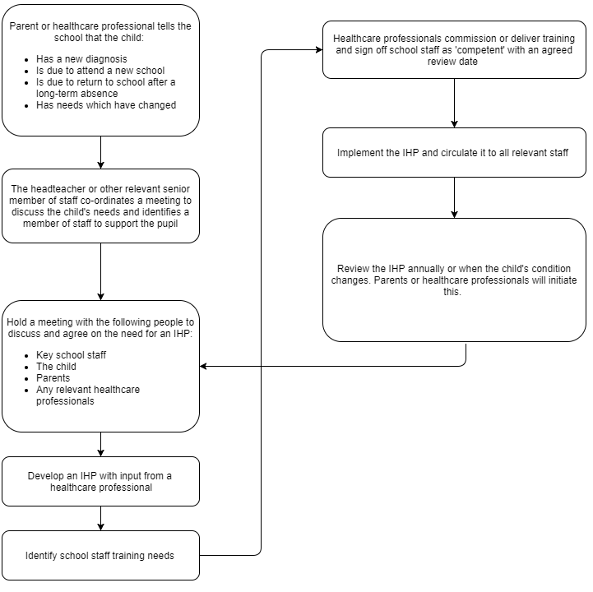

Appendix 2
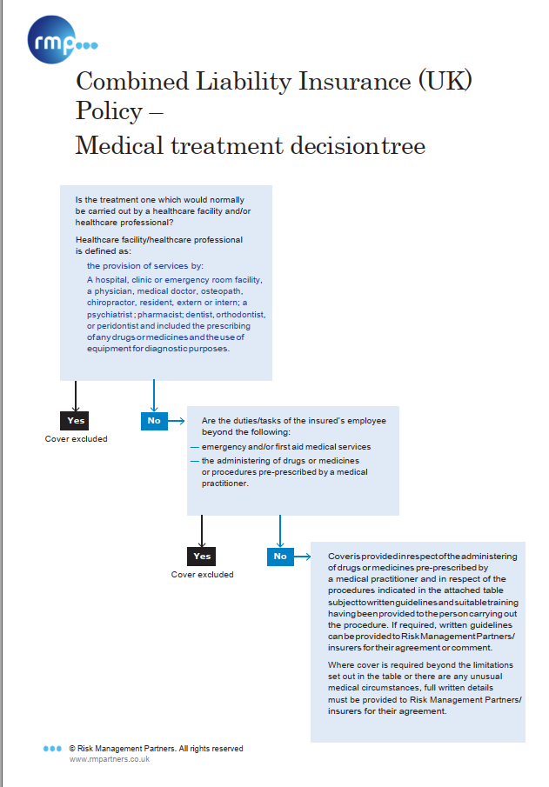
Appendix 3
School Treatment Insurance Conditions – Medical Malpractice

Medical Malpractice Insurance is included within the schools Public Liability insurance cover

It is a condition of the Medical Malpractice policy that the insured shall ensure:

a) Each child who receives a medical procedure or intervention* in school has a specific individual care plan signed off by the child’s parents, the school head teacher and the child’s General Practitioner or supervising consultant.

b) The care plan must include full details of the emergency procedures in the event of a medical emergency.

c) The child’s parents have provided written consent for a non Medical or Healthcare practitioner to provide the medical procedure or intervention to their child.

d) The employee who is providing the medical procedure or intervention has received full training from a registered Medical or Healthcare professional, and has been signed off as fully competent in the procedure they are providing.

e) The employee who is providing the medical procedure or intervention has provided written confirmation that they have read and understood the individual care plan.

Zurich Insurance (From 1st April 2022)

** Medical procedures & interventions are described in the attached document “Medical treatment table”. Procedures marked “Yes” are covered by the Public Liability policy, any marked “No” are covered by the Medical Malpractice policy, for which schools should abide by the conditions above.

Please contact the Councils Insurance Team for further details on 07767 005479

Appendix 4
