Yr 3 and 4
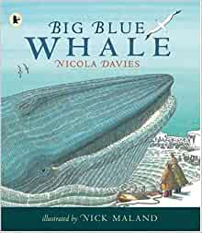

In class, we have been reading Big Blue Whale by Nicola Davies. Having worked on this since February, we would like you to use all the skills and vocabulary we have practised to finish the unit at home and write an informative article persuading people to protect the blue whale:

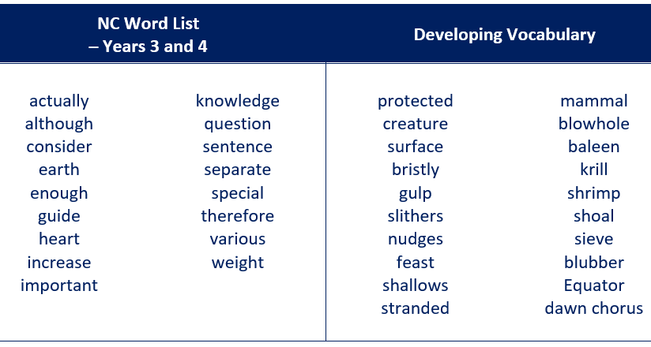
Key skills to include Key vocabulary to include
- Use adverbs to express time, place and cause
- Build an increasing range of sentence structures
- Use headings and sub-headings to aid presentation
- Assess the effectiveness of own and others’ writing

In class, we watched a video link to the BBC’s Blue Planet along with several other clips. We also made notes about blue whales using some of the websites below. We have thought about where whales live and travel to, what and how they eat, what they do in different seasons, how long they live for and how they breathe. You may want to remind yourself what we learnt:
https://www.youtube.com/watch?v=1fzT6ifrhL8
http://www.bbc.co.uk/nature/life/Blue_Whale#p004t035
http://www.wdcs.org/wdcskids/en/story_details.php?select=584
https://www.natgeokids.com/uk/discover/animals/sea-life/10-blue-whale-facts/
https://uk.whales.org/whales-dolphins/species-guide/blue-whale/
https://www.whalefacts.org/blue-whale-facts/

Monday
Have a go at some of the tasks we did in class to practise the skills we have focused on this term:

Task 1
These words are conjunctions: because, while, before, after, when. They join sentences together to add and extend detail.
Write sentences with interesting facts about whales using these conjunctions to extend and add detail.

Task 2
These adverbs show time: first, then, now. Can you think of any others?
These adverbs show place: up, down, around, north, south, out, away. Can you think of others to show where whales swim?
Edit your sentences to include these adverbs.

Task 3
Compose some exclamation sentences that tell you about whales in an enthusiastic way.
e.g. What a magnificent creature a whale is! How amazing whales are! How unbelievably enormous a whale is!

Tuesday

Read this poem by Tony Bradman. You will be using your research from this week to write a poem like it on Friday.
Leave the whales alone, please
They don’t do anything wrong;
They swim in every ocean,
And fill them with their song

Leave the whales alone, please,
Like us they’ve a brain;
But if we don’t start using ours,
We won’t see them again.

Leave the whales alone, please,
We need them in our seas;
We need their life and beauty,
And all they need is peace

Leave the whales alone, please;
Let them live their lives,
Let them leap, and swim, and sing,
Let the whales survive!

Watch the video
https://vimeo.com/109138073

Think about these questions:
- How does the girl feel at the beginning of the video?
- Why do her feelings change throughout the video?
- What are her thoughts about keeping whales in captivity?

Write a diary entry as the girl for when she sees the killer whale in the tank to when she sees them in the ocean.
Include her thoughts and feelings about keeping whales in captivity.

Wednesday and Thursday
Use the websites and any non-fiction books that you have to find out more about hunting, pollution, fishing and how humans affect sea life in a negative way.
- The Whale and Dolphin Conservation Society have produced a variety of materials for teachers. Look at the PowerPoint presentations: https://uk.whales.org/whales-dolphins/educational-resources/
- WWF website explains bycatch and effects of climate change: www.wwf.org.uk
- Watch the message from Sir David Attenborough: https://www.youtube.com/watch?v=unOqVELbTr0
Discuss with an adult why humans continue to undertake activities which harm marine life. Could it be that people don’t understand what they are doing or think that what they are doing is more important?
Record your findings as a spider diagram in your workbook.

Friday
Using your sentence work and research from this week, write your own poem is the style of Leave the whales alone, please.

Use a repeating first line of your own and 4 lines for each stanza. Two ideas for the first line are; Let the whales go free, now or Stop polluting the waves, please. You can use your own.
Write your poem and perform it to the people in your house. You could record it and post it on Twitter if you want to.

Bonus work if you’ve finished everything else

Plan and write
Write an article for an environmental website, such as WWF’s Go Wild website, or an environmental magazine, such as National Geographic Kids, a poster or a leaflet. This article will do two things:
- give information about whales
- persuade someone to do something to protect whales
You might want to have a look at some to remind yourself what they look like and how they read.
https://www.natgeokids.com/uk/teacher-category/animals/

You should find examples of these structure and layout features
- persuasive language e.g. alliteration, repetition
- Written in logical order
- 2nd person or 3rd person to talk directly to the reader
- opening statement, sub-headings, closing statement

Don’t forget to plan and organise your writing to show which information you need to include where. Don’t forget to plan the layout of your information text too e.g. draw a diagram with boxes with headings to show where the introduction, information paragraphs and final paragraph, images and banners will be.
Write the sections of your article. Your introduction and conclusion should persuade the reader to take action to protect the whales. Remember to make them sound wonderful and use phrases to emphasise the danger they face.
When you have finished, edit and evaluate your article by reading it to someone else. Does it persuade them to take action?
Challenge: You may want to include information about other sea creatures you have researched and the threats they face.

