Uploading your work to the school website

When children have completed a homework task and would like to submit it to their teacher they can respond to the homework by uploading work. They are only able to upload one item per homework. This guide will show you how to upload either a single document or a folder with multiple documents in.

For both options you will first need to log into your child’s student area of the website with the username and password in the front of their home learning book.

<http://www.tarporleyce.cheshire.sch.uk/>

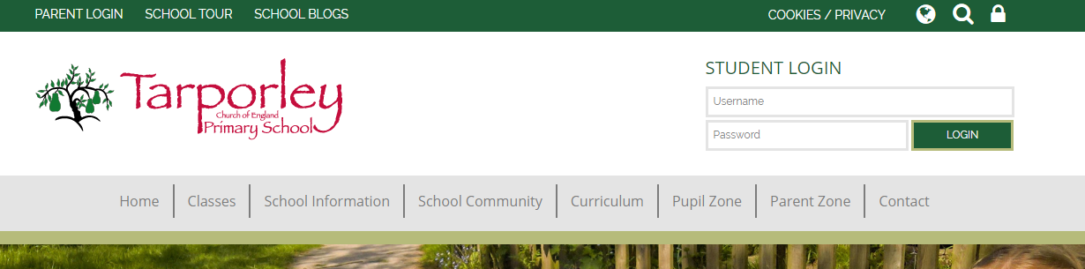

# Once logged in select the homework activity or timetable that you would like to respond to

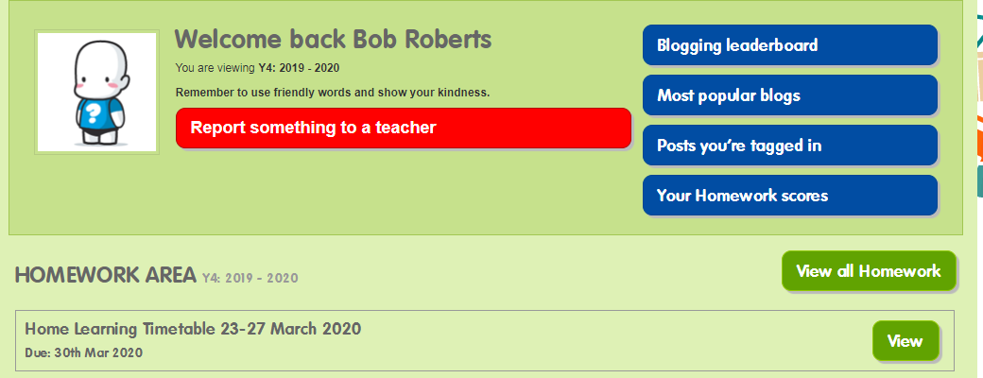

On the following page, click ‘Upload your homework’ and a window will open where you will be able to select the file that you would like to upload.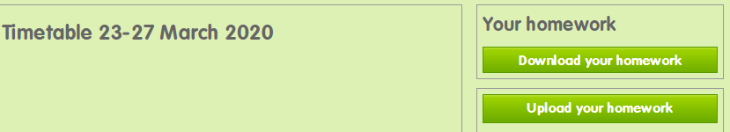

Once the file has been uploaded the following message will appear.

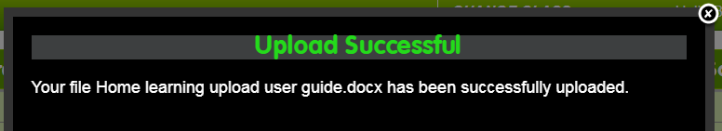

This window can be closed with the x in the top right-hand corner. The homework file that has been uploaded will appear underneath the ‘Upload your homework’ button.

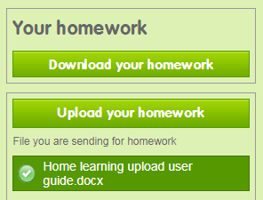

# Uploading multiple documents

To upload more than one document you will first need to create a folder with all of the documents in that you would like to upload. You will then follow the same process as above up to the point where you select the document.

After clicking the ‘Upload your homework’ button, locate the folder that you want to upload.

Right click on the folder, scroll down to ‘Send to’ and then click on ‘Compressed (zipped) folder’.

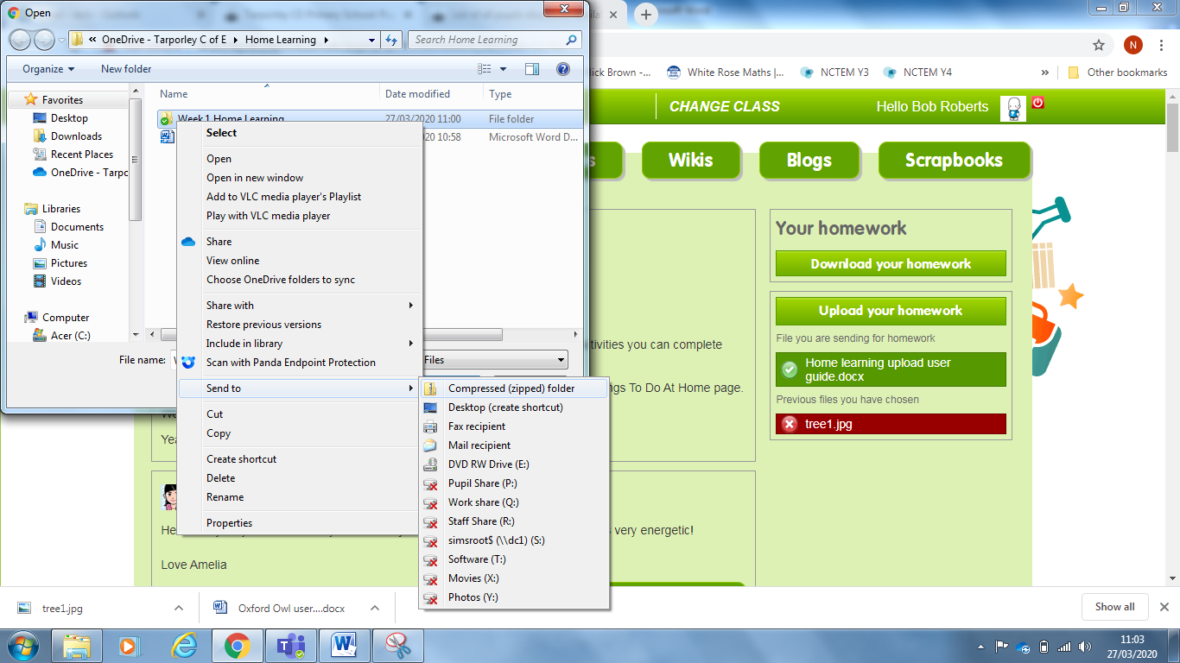

A new folder will then appear. The icon will have zip running through it and the file type will read ‘Compressed (zipped) Folder’. Select this folder and click ‘Open’.

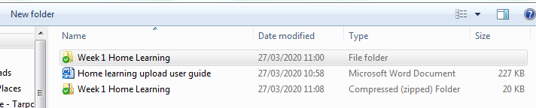

As before, the following screen will appear which can be closed.

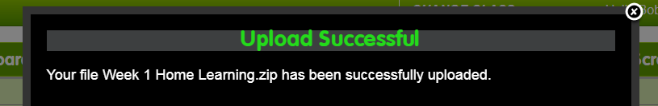

The folder that you have uploaded will appear and any previous uploads will have been removed.