 | Little Wandle - Letters and Sounds  EYFS Phonics Home Learning | 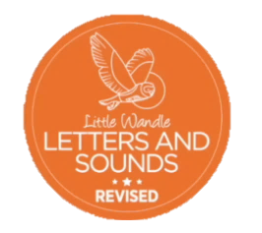
 | Phase 2 – Autumn 2 Week 3
Please support your child to practise and reinforce the phonemes and graphemes we are learning in school. More information and support can be found on the Little Wandle website - https://www.littlewandlelettersandsounds.org.uk/resources/for-parents/
Phonemes we will be focusing on this week in school –
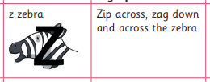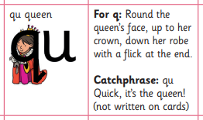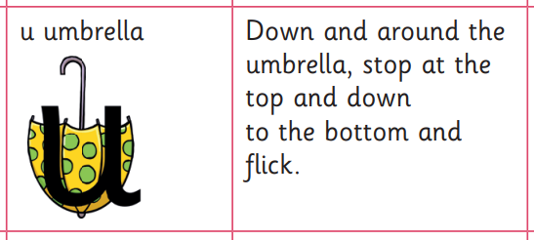

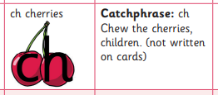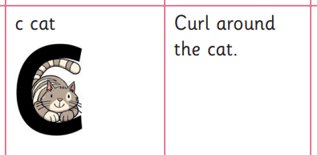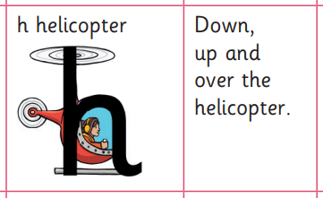

We will be reading and writing these words. Can you spot this week’s phonemes?
zip quick chip zap chop quack buzz rich quit

Can you say the actions as you trace over the letter?
Push a line, slide down, push a line on the ground

We will be practising tricky words. Can you spot the tricky part of the word?

and has his her go no to into

