 | Little Wandle - Letters and Sounds  EYFS Phonics Home Learning | 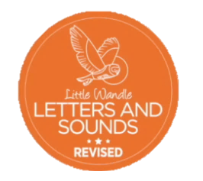
Phase 3 – Spring 2 Week 2
Focus – double letters/ longer words
Please support your child to practise and reinforce the phonemes and graphemes we are learning in school. More information and support can be found on the Little Wandle website - https://www.littlewandlelettersandsounds.org.uk/resources/for-parents/
Phonemes we will be focusing on this week in school –
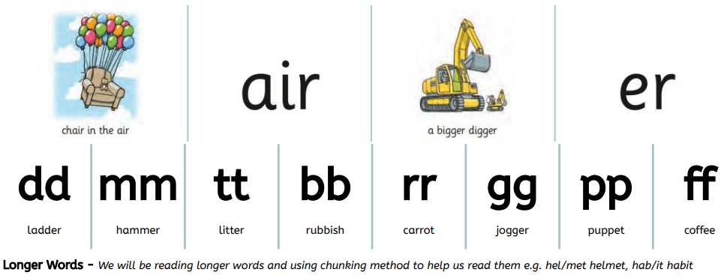

We will be reading and writing longer words. Can you spot this weeks phonemes?
bigger chair fair rubber shimmer butter supper chatter muffin mutter buzzer cannot laptop seven fantastic comic

We will be reading sentences. Can you spot any tricky words?
This pink chair is bigger than the red chair.
We feed the chicken and rabbit supper.

We will be practising tricky words. Can you spot the tricky part of the word?
and go no of

