 | Little Wandle - Letters and Sounds  EYFS Phonics Home Learning | 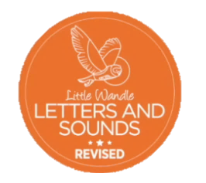
 | Phase 3 – Spring 2 Week 1
Please support your child to practise and reinforce the phonemes and graphemes we are learning in school. More information and support can be found on the Little Wandle website - https://www.littlewandlelettersandsounds.org.uk/resources/for-parents/
Phonemes we will be focusing on this week in school –
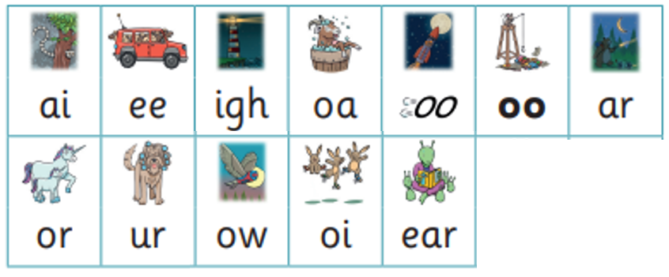

We will be reading and writing compound words and words with two syllables.
tail deep fight load food hard born surf foot town boil hear

We will be reading sentences. Can you spot any tricky words?
The man has a long boat. He has buckets of carrots. The night is dark. The cat has a curl in his tail. We put the rabbit down on the carpet.

We will be practising tricky words. Can you spot the tricky part of the word?
is as his has the I

