TARPORLEY CE
PRIMARY SCHOOL

Tarporley Church of England Primary School is a welcoming and friendly Church school that provides high quality education for children aged 5-11. As a Church school we hold our Christian Values at the heart of everything we do. These are: LOVE, FRIENDSHIP, TRUST, HOPE, FORGIVENESS, JOY & CELEBRATION

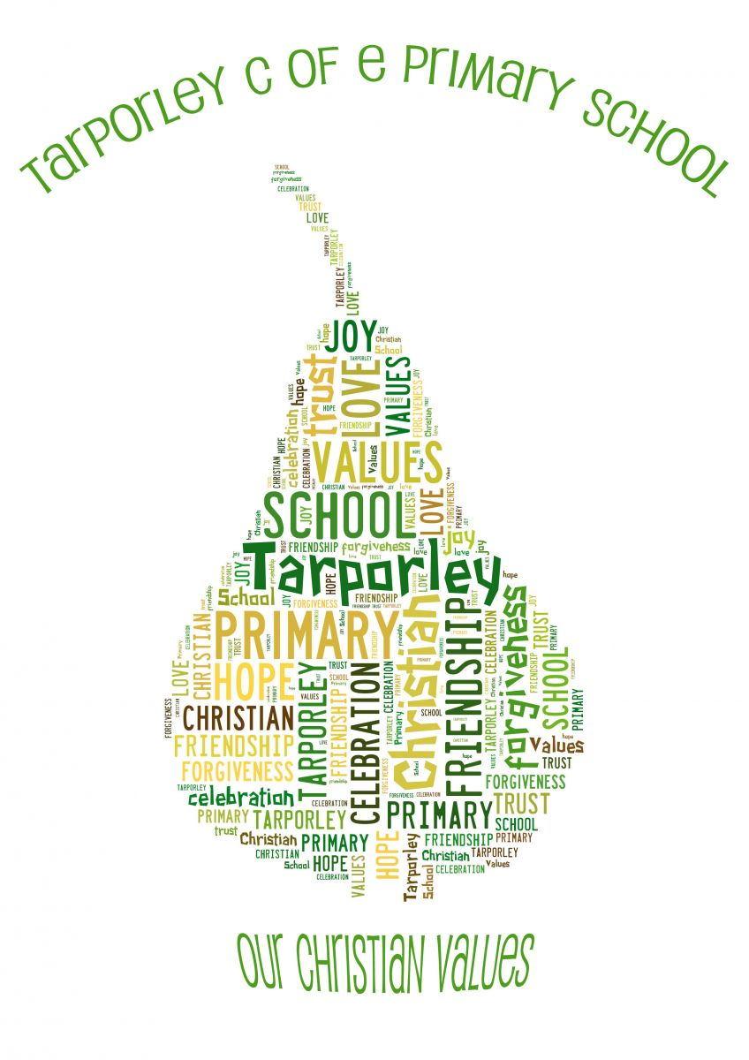

It is very important to us that the children are happy and experience the best education possible. We value strong links and a close partnership between home, church and school and recognise the importance of trust and shared responsibility in education.

Science Policy

Tarporley CE Primary School
Science POLICY

Science learning is a combination of skills and knowledge. Each unit of Science being planned includes opportunities for children to review and extend upon their knowledge in that area as well as apply and develop their scientific enquiry.

Aim:
Children learn best when teaching and learning activities enthuse, engage and motivate them to learn, and when they foster their curiosity and enthusiasm for learning.

Teachers aim:
• Well-judged and effective teaching strategies successfully engage pupils in their scientific learning – a hook, learning journey and high quality outcome will be in evidence in each unit of learning
• To use their expertise, including their science subject knowledge, to develop pupils’ knowledge, skills and understanding in a structured way, across the range of subjects and areas of learning.
• To develop well framed questions, knowledgeable answers and the use of discussion, promotes deep learning
• To ensure an appropriate ratio of exposition to learning-activity in their teaching
• To develop home-learning is set to nurture children’s enthusiasm and curiosity, and develop their understanding in areas under.

Planning

Differentiation

We recognise that there are children of widely different scientific abilities in all classes, so we provide suitable learning opportunities for all children by matching the challenge of the task to the ability of the child. We achieve this in a variety of ways by:
- setting common tasks which are open-ended and can have a variety of responses;
- setting tasks of increasing difficulty (not all children complete all tasks);
- grouping children by ability in the room and setting different tasks to each ability group;
- providing resources of different complexity depending on the ability of the child;
- using classroom assistants to support the work of individuals or groups of children

Assessment:
Children learn best when assessment informs teaching so that there is provision for support, repetition and extension of learning for each child, at each level of attainment.
• Children who are motivated to learn through differentiated learning-activities that build on their prior attainment and issue challenge that is pitched at a level that is achievable when they work hard and try their very best.
• The pace and depth of learning is maximised as a result of their monitoring of learning during lessons and any consequent actions in response to pupils’ feedback
• Teachers to have high expectations for all children, and plan, resource and direct differentiated learning activities that give support and issue challenge for all.
- Children’s attainment is logged onto ‘Insight’ an online tracking system at the end of each term.
- Children to be assessed on their understanding of half-termly topics by use of a test OR STEM projects in line with implementing knowledge and skills taught during each half-term topic.

Monitoring and review

- The science subject leader is responsible for the standard of children’s work and for the quality of teaching in Science. The work of the subject leader also involves supporting colleagues in the teaching of science, being informed about current developments in the subject and providing a strategic lead and direction for the subject in the school.
- The science subject leader is responsible for giving the headteacher an annual summary report in which he evaluates the strengths and weaknesses in the subject and indicates areas for further improvement.
- The science leader is responsible for carrying out annual book scans, as well as, monitoring/observing the teaching of science throughout the school
- The Science leader is responsible for any CPD needs of staff.

Science Resources
• Science resources used to support children’s understanding of new concepts (scientific vocabulary, books, posters etc.)
• Concrete materials to assist particularly with more abstract themes.
• Specialist resources used to build on children’s skills.
• Related out-of-school and enrichment activities.
- STEM boxes, including challenges to aid assessment.

Created: Sep 2023
To be reviewed: Sep 2024

