TARPORLEY CE PRIMARY SCHOOOL
Let Your Light Shine (Matthew5)

Tarporley Church of England Primary School is a welcoming and friendly Church school that provides high quality education for children aged 5-11. As a Church school we hold our Christian Values at the heart of everything we do. These are: LOVE, FRIENDSHIP, TRUST, HOPE, FORGIVENESS, JOY & CELEBRATION

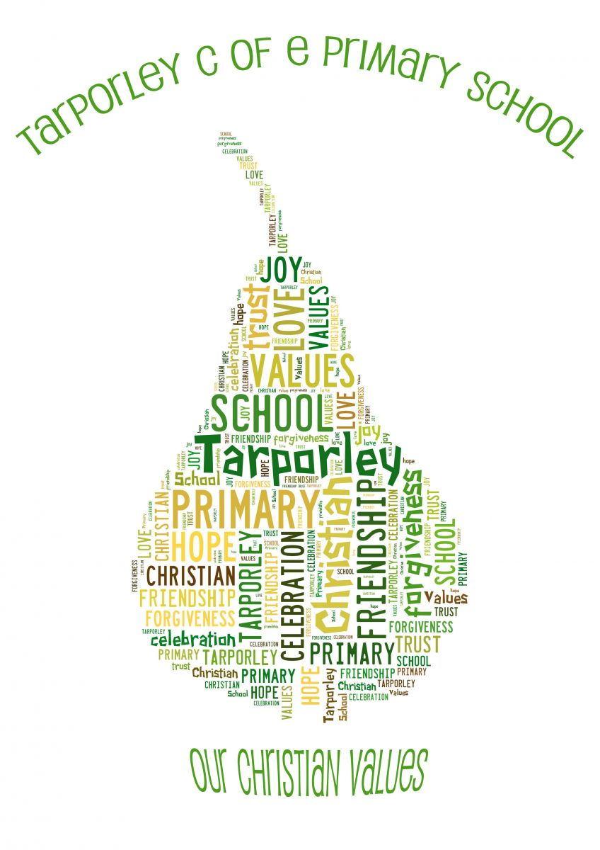
It is very important to us that the children are happy and experience the best education possible. We value strong links and a close partnership between home, church and school and recognise the importance of trust and shared responsibility in education.

Music Policy

Tarporley CE Primary School
MUSIC POLICY

Our Curriculum

Curriculum Statement

As a Church School, we approach all that we do through our Christian Values which are embedded throughout our curriculum. They are…

Joy, Celebration, Hope, Friendship, Forgiveness, Love, Trust

Our Christian Values are integral to all that we do and form the bedrock of our attitudes and approach.

We want all of our children to Let their Light Shine (Matthew 5).

We have a clear and shared vision and language to talk about our curriculum, and now more than ever, we recognise that placing books and reading at the heart of a curriculum is the best way to raise standards and close the gap. Research shows that vocabulary is the single most significant predictor of future success. Therefore, developing in our children a love of books, words, language and literature not only enhances our provision by placing reading at the centre, but also creates an environment for accelerated progress. With this in mind, we have placed BOOKS at the heart of what we do.

We want our curriculum to:

Demonstrate BRAVERY – we want our teachers to be ambitious when planning our curriculum with high expectations of all learners. We want our learners to be brave, willing to take risks and get things wrong, and show resilience alongside a strong desire to learn and grow

Be OUTWARD-FACING – our curriculum will look beyond our school to our local community and will encourage children to see themselves as part of the wider national and global community. They will learn from other countries, faiths and cultures and we will celebrate differences while recognising that all life on Earth is precious. Our children will understand they have the power to affect change through courageous advocacy and both ask and answer Big Questions

Create memorable OPPORTUNITIES – we want our children’s time at Tarporley to be filled with happy memories that spark their curiosity, motivate them to reach their full potential, ensure learning is ‘sticky’ and instil in them a life-long love of learning. Our broad and ambitious curriculum will embrace learning outside the classroom, and will recognise the importance of cultural capital in preparing our children for life and learning beyond our school

Develop KNOWLEDGE and SKILLS – we recognise that knowledge is key. Our coherently planned and sequenced curriculum ensures all children can achieve, make sense of the world and make informed judgements and decisions. Vocabulary development will be at the heart of this. Our children will leave us with the skills they need to thrive in the next stage of their learning

Nurture SPIRITUALITY – led by our Christian Values, staff will nurture the whole child by developing their social, moral, cultural and spiritual well-being. We recognise spirituality as ways of being with God and the ways God is with us

…while always having high-quality BOOKS and reading at the heart of our teaching and learning!

Intent

‘Music is a universal language that embodies one of the highest forms of creativity.’ (National Curriculum)

At Tarporley C of E Primary School, our music curriculum aims to inspire creativity, self-expression and build self-confidence while developing and fostering a lifelong love of music. We hope to encourage all our children on their musical journey as well as giving them opportunities to connect with others in their school, family and wider community. We aim to encourage awareness, enjoyment and appreciation of Music in all its forms as we expose the children to a diverse, multicultural musical experience. Through providing opportunities to listen and appraise, sing, perform and compose we aim to build confident, reflective musicians who can respond on both an emotional and intellectual level. They will develop a growing awareness of the Musical elements: pitch, duration, dynamics, tempo, timbre, texture and structure and appropriate musical notation.

As a Church of England Primary school, we also appreciate that there is a spiritual side to music and we aim to use music to enable children to be closer to God and to learn and know more about God through music.

Implementation

The main elements of Music are taught by class teachers using Charanga, a high quality, up to date, clear and comprehensive online scheme of work. In addition, our curriculum is enhanced with a range of listening opportunities taken from the New Model Music Curriculum and some listening and composing units taken from the BBC 10 Pieces resources. Charanga can also be supplemented by the subject leader and teachers own input to match and complement the curriculum.

In addition to classroom lessons, Music is embedded through weekly Collective Worship and singing practises. We also have a range of live performance and the opportunity for learning instruments from specialist peripatetic teachers. We have a choir which takes part in many community events alongside Young Voices and AmaSing. There is also the opportunity for children to join one of our Rocksteady bands and all Year 4 children have the opportunity to learn a brass instrument. In order to help our children read musical notation, all Year 3 children are given a recorder, which they learn throughout KS2. As a school we regularly perform at our local church for Harvest, Christmas and Easter services. KS1 do a bi-annual visit to the Primary Liverpool Philharmonic Concert.

We recognise that there are children of widely different musical abilities in all classes, so we provide suitable learning opportunities for all children by matching the challenge of the task to the ability of the child.

Impact

We aim to create confident, reflective musicians where all children, regardless of their ability or SEND, are able to enjoy music however they chose, either as a listener or performer. We want every child to achieve age-related expectations in music as well as developing each child personally in their creativity, independence and self-reflection. We hope the seeds sown during their primary journey will continue to grow as our children move on and that they will leave with a heightened awareness of the musical opportunities available both in and outside of school.

Music is part of our whole school monitoring and review schedule. This is carried out by the Music lead. Evidence of each unit of work is uploaded to staff share. As a minimum a photograph and or video of the pupils taken at the beginning, middle and end of each unit is saved for that academic year.

Review: April 2023

