 | Little Wandle - Letters and Sounds  EYFS Phonics Home Learning | 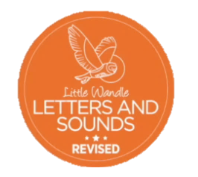
 | Phase 2 – Autumn 1 Week 2
Please support your child to practise and reinforce the phonemes and graphemes we are learning in school. More information and support can be found on the Little Wandle website - https://www.littlewandlelettersandsounds.org.uk/resources/for-parents/
Phonemes we will be focusing on this week in school –
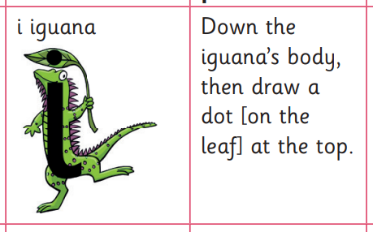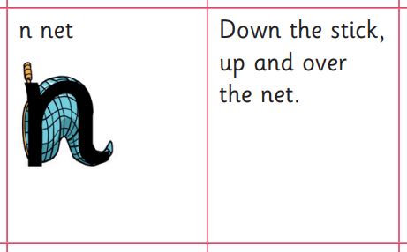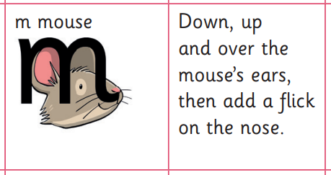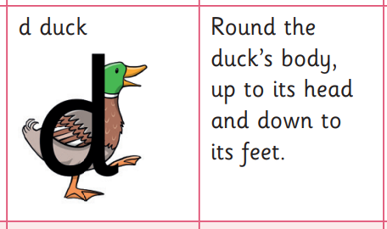

We will be learning to recognise these graphemes.

We will be reading these words. Can you spot this week’s phonemes?

sit nap man dip

pat sad nip mat

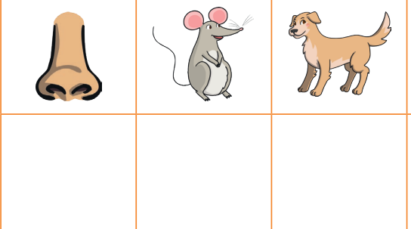
Can you identify the initial sound for these pictures? 