TARPORLEY CE PRIMARY SCHOOL
Let Your Light Shine (Matthew 5)

Tarporley Church of England Primary School is a welcoming and friendly Church school that provides high quality education for children aged 5-11. As a Church school we hold our Christian Values at the heart of everything we do. These are: LOVE, FRIENDSHIP, TRUST, HOPE, FORGIVENESS, JOY & CELEBRATION
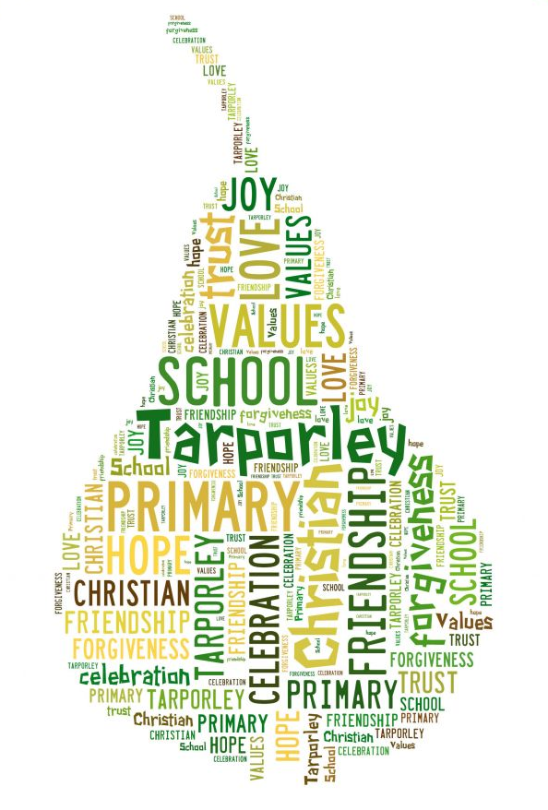
It is very important to us that the children are happy and experience the best education possible. We value strong links and a close partnership between home, church and school and recognise the importance of trust and shared responsibility in education.

Collective Worship Policy

Tarporley CE Primary School Collective Worship Policy

At Tarporley Church of England Primary School the daily act of collective worship is viewed as our unique heartbeat and is an integral and important part of school life. It is a time where we come together to share our love of God, talk with God and celebrate our achievements (and sometimes failures) together. The worship of the school is invitational, inclusive, inspiring welcoming and based on promoting the Christian values which permeate the ethos of the school.

Worship helps us to:
- praise and give thanks to God
- reflect on the meaning and purpose of Christian life
- focus on our Christian Values and Christian character
- develop meditation and thought through stillness and reflection
- learn and reflect on the life of Jesus and of the peoples of the Bible
- explore religious ideas and the big questions of life
- celebrate festivals and national events
- learn from the experiences of others
- develop community spiritual awareness, promote a common ethos, shared values and reinforce positive attitudes and tolerance of others
- come together to worship as a school family

The wooden cross in the Hall is a reminder of our strong Christian association. A candle is used as a point of focus in assembly, alongside music and images. Links between St Helen’s Church and the school are long established; we hold services in church at least seven times a year for Harvest, Christmas, Easter, end of term and a service for the pupils leaving school in July. These services bring parents and children together. The Vicar takes collective worship in school every other week and contributes to all the Church Services. We also have strong links with the Baptist and Methodist Church and the church leaders lead a collective worship in school once a fortnight. The Vicar and a member of the B&M church work with the collective worship lead to plan termly worship.

OUR VISION - ‘Let Your Light Shine’ (Matthew 5),
Learning within a Christian Heritage, since 1849
With Christian values at our core, we nurture a love of learning and inspire everyone to let their light shine and glorify their good deeds. Our school community centres on the needs of our children who are encouraged to be the best they can be in all aspects of school life and to embrace opportunities as their journey continues.

At Tarporley CE Primary we aim to:
- Create an enjoyable, safe and nurturing ethos that allows all individuals to develop spiritually, morally and socially.
- Promote caring, sensitive and inclusive attitudes where individuals feel confident, secure, valued and respected by others.
- Provide a broad and balanced curriculum which challenges, celebrates and develops the potential of each child.
- Create a stimulating environment, which encourages enthusiasm for lifelong learning and promotes an expectation of high standards.
- Develop a successful and lasting partnership between home, school, the Church and the wider community.
OUR PRINCIPLES - At Tarporley Church of England Primary School are that we:
- Keep the child at the heart of everything we do
- Value and respect everyone and everything
- Demonstrate a positive approach
- Work as a team
- Embrace challenges and opportunities

We pride ourselves on being a welcoming and friendly Church school that holds our Christian Values at the heart of everything we do.
These are: LOVE, FRIENDSHIP, TRUST, HOPE, FORGIVENESS, JOY & CELEBRATION

Our children and staff are all encourage to show Bravery, be Outward facing, embrace Opportunities as they acquire both Knowledge and Skills that is enhanced through their Spirituality (BOOKS approach) as they strive to 'Let their Light Shine.'

Legal Requirements
We acknowledge the legal requirement stated in the 1988 Education Reform Act 6 (1) and 9 (3), which states the need for each child to attend a daily act of worship either as a whole school, class or group. Parents have the legal right to withdraw their children from the act of worship either partially or wholly. Any parents wishing to do so should contact the Headteacher. Teachers also have the right to withdraw from leading and taking part in worship.

Organisation
We aim to provide a variety of worship experiences for the children. Our current schedule is as follows:

Monday Key Stage worship led by the Headteacher / Deputy Head

Tuesday Key Stage worship led by a visiting church leader or teacher

Wednesday Class worship led by the class teacher

Thursday Key Stage hymn practice, with prayer/reflection time, led by the
Music coordinator and another teacher.

Friday Key Stage celebration worship led by the Headteacher / Deputy to
which parents of the Star of the Week and full sticker book awards are
Invited.

Once every half term and at all Church services, the Ethos group will plan and lead a collective worship on one of our Christian Values. The Ethos group meet to discuss and monitor the Christian Ethos of the school, talk about issues and worship.
Each class leads a class worship once during the school year when parents, relatives and friends are invited to join us.
In addition to this, visiting groups and individuals are welcomed into the school regularly to lead worship.

Planning for worship is based first of all on the Christian Calendar, and in particular on the advice from the Diocese. Particular events are programmed for each term and a thematic approach is used. A wide range of resources is available for the preparation of themes and a variety of formats is used. Each act of worship includes a song, a story/poem/factual account/discussion with the children and a prayer. Music is used to introduce and end the worship; music is sometimes used as the worship theme.

Children are encouraged to take an active part in all collective worship eg: lighting the candle, sharing a reflection, leading the prayers, selecting music, leading responses, delivering information, important messages to other pupils, talking about life experiences, reading aloud, asking and responding to questions raised.

The act of collective worship should last approximately 15 minutes.

Class Worship

Every Wednesday, worship takes place in classrooms and is led by teachers and pupils. Resources such as HeartSmart and Picture News are utilised to enrich pupils' sense of belonging and spirituality and to allow them to explore their relationship with God. The resources encourage pupils to look inwards to understand themselves better and to recognise the value each and every one of us has, and outwards to the wider world and God's creation. Picture News in particular supports our pupils to learn about the world and learn from the world through topical stories and themes.

Prayer and Reflection
Collective worship always includes a time of prayer and/or reflection, including hymn practice. A range of prayers is used including the Lord’s Prayer. They are introduced in an appropriate manner with a short time of quiet. At the beginning of the whole school worship led by the Headteacher or Deputy Head, a time of
reflection and quiet is encouraged by the lighting of candles. A cross is also displayed above the altar table.
At the beginning of the lunch hour, grace is said by either an adult or child in each class. Teachers make an individual decision about whether to say a prayer with their class at the end of the school day.
The school has a Prayer Tree, in the community entrance area of the school. Children are encouraged to say a short prayers and clip the leaves onto the tree. Each classroom has an area for reflection which children are encouraged to use when they want to pray or reflect.

Other Faiths
Although our worship reflects our Christian beliefs and values, we are committed to respecting each other’s faith stance and culture, showing tolerance and understanding regardless of pupils’ beliefs. The class-led acts of worship may portray other cultures and beliefs as they reflect the RE studied as part of the curriculum requirements.

Equal Opportunities and special needs issues
All pupils, regardless of academic ability, age, gender and ethnic origin will have access to a wide range of appropriate activities to support their understanding of R.E. At each Key Stage, the teacher will draw from other religions as appropriate to acknowledge and celebrate the religious beliefs of the children within the class.

• Children may be withdrawn from R.E. lessons and collective worship at the wish of their parents. The Headteacher will ensure that suitable provision is made for such pupils.

Reviewed: February 2022

