TARPORLEY CE
PRIMARY SCHOOL
Let Your Light Shine (Matthew 5)

Tarporley Church of England Primary School is a welcoming and friendly Church school that provides high quality education for children aged 4-11. As a Church school we hold our Christian Values at the heart of everything we do. These are: LOVE, FRIENDSHIP, TRUST, HOPE, FORGIVENESS, JOY & CELEBRATION
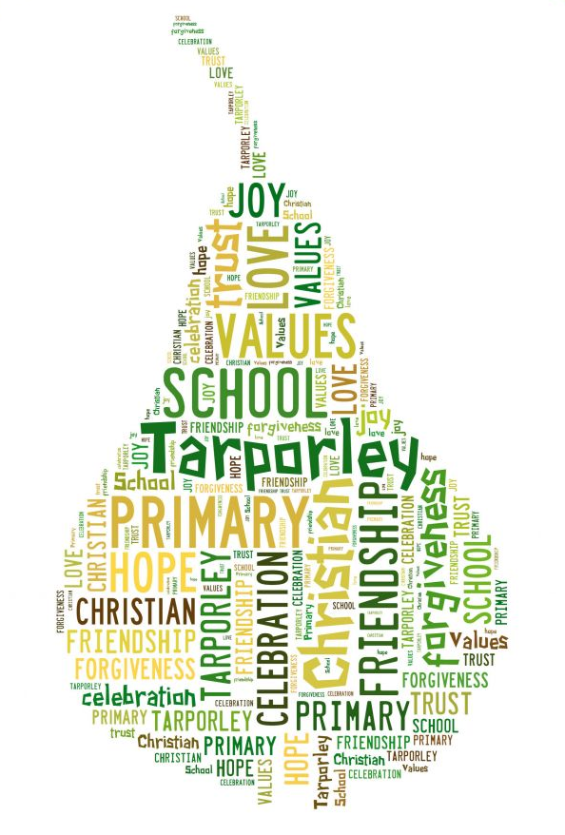
It is very important to us that the children are happy and experience the best education possible. We value strong links and a close partnership between home, church and school and recognise the importance of trust and shared responsibility in education

Marking & Feedback Policy

Marking and Feedback Policy

At Tarporley CE Primary School, we provide equality of opportunity. We believe that inclusive education means the greatest degree of match or fit between the individual learner’s requirements and the provision that is in place for him or her. At the heart of our thinking is the belief that children should be actively included and fully engaged in their learning.

We see the school as a working community, which respects not only diversity of appearance but that of opinions, beliefs, practices, ideas and abilities. We endeavour always to represent an inclusive school family.

This policy sets out guidelines for marking and feedback which encompass the school’s philosophy for learning and teaching.

Aims:
Effective marking is an essential part of the education process. At its heart, it is an interaction between teacher and pupil; a way of acknowledging pupils’ work, checking the outcomes and making decisions about what teachers and pupils need to do next, with the primary aim of driving pupil progress. This can often be achieved without extensive written comments.

We aim to provide a system of marking that is consistent and continuous across each stage within our school. Marking will inform planning, be diagnostic and enhance children’s learning by ultimately offering guidance on how work can be improved. We mark positively to enhance self-esteem and confidence. We recognise that marking must be age appropriate. Oral feedback is used to reinforce recorded marking, or instead of recording for younger children. Children will be encouraged to read through and proofread their work before presenting it to be marked as a strategy to develop self-reflection and self-evaluation against the learning objectives.

Teacher Workload

Written feedback on pupils’ work can lead to an excessive workload if not managed carefully. Here at Tarporley CE Primary School, teachers mark pupils’ exercise books and add a next step if appropriate. It is expected that feedback will be both written and verbal in KS2 but it may be predominantly verbal in KS1. Live marking is encouraged during the lesson so pupils can benefit from on-the-spot feedback.

All marking should be meaningful, manageable and motivating.

- Meaningful: approaches to marking and feedback vary according to group, subject, and what works best for the pupil and teacher in relation to any particular piece of work. Teachers are encouraged to use their professional judgement and knowledge of their pupils to adjust their approach as necessary. They are trusted to ensure that the outcomes inform subsequent planning and teaching.

Our marking should serve a single purpose – to advance pupil progress and outcomes. Teachers should be clear about what their marking and feedback are trying to achieve and the best way of achieving it. Crucially, the most important person in deciding what is appropriate is the teacher. Oral feedback, working with pupils in class and reading their work all help teachers understand what pupils can do and understand. Every teacher will know whether they are getting useful information from their marking and whether pupils are progressing.

- Manageable: marking practice is proportionate and considers the frequency and complexity of written feedback, as well as the cost and time effectiveness of marking in relation to the overall workload of teachers.

The time taken to mark does not always correlate with successful pupil outcomes and leads to wasted teacher time. Examples of disproportionate marking practice include: extensive comments which children in an EYFS or KS1 class are unable to read, or a written dialogue instead of a conversation. If teachers are spending more time on marking than the children are on a piece of work, then the proportion is wrong and this should stop.

- Motivating: marking should help to motivate pupils to achieve. This does not mean always writing in-depth comments or being universally positive: sometimes short, challenging comments or oral feedback are more effective. If the teacher is doing more work than their pupils, this can become a disincentive for pupils to accept challenges and take responsibility for improving their work.

An important element of marking is to acknowledge the work a pupil has done, to value their efforts and achievement, and to celebrate progress. However, there are many ways to do this without extensive marking. Too much feedback can take away responsibility from the pupil, detract from the challenge of a piece of work, and reduce long term retention and resilience-building.

Expectations:
In a nutshell:
- Feedback is understood by the children – be this through written or verbal comments
- Feedback is acted on
- Feedback is used as part of a two-way dialogue to improve learning and progress
- Feedback is modelled by children when evaluating their own work
- Feedback is meaningful, manageable and motivating

The question teachers must ask themselves is: Is my marking and feedback making an impact on the quality and rate of learning and progress?

We mark and give feedback on children’s work in order to:
- Show work is valued and to praise effort and progress
- Give feedback to children on their achievements and the next steps in their learning
- Inform future planning and learning
- Evaluate and assess children’s learning

We respond to children’s work in a variety of ways:
- We mainly mark in purple or a colour that contrasts with the child’s work
- Recorded feedback should be clearly written, in line with the Handwriting Policy
- Negative comments are not acceptable
- Written and verbal feedback should be both celebratory and developmental. Developmental marking which suggests next step should refer to the learning objective
- We appreciate well-presented work and neat handwriting and will praise these. However, marking will not always focus on surface features unless this has been the focus on the lesson and is identified on the context label
- Themes will run through, i.e. referring back to previous marking commenting on progress, etc.
- Time will be provided for children to read marking and respond in green pen
- Peer assessment / marking should be recorded in children’s books on the context label and should be carried out regularly
- It is expected that marking and feedback will be mostly formative however, with the older children, it is sometimes appropriate to share summative marking in order to support progress
- Marking should directly link to the lesson’s objective written on each context label

Pupils with SEND
Children with SEND follow the marking policy unless feedback needs to be in their most effective form of communication according to their special educational needs or disabilities.

Context labels
At Tarporley CE, we use context labels as a means of both sharing the learning objective and indicating pupils’ progress towards achieving the learning objective. Pupils use the label as a means of self-assessment and peer assessment. For the majority of lessons, pupils will stick their labels in their books. For longer pieces of written work that are completed over several days, one label may be appropriate.

Key Stage 1 pupils use these labels:

Date |  |  |  | Self | Peer | Teacher
LO: To

Independent | T | TA | Group |  | Verbal Feedback

In Key Stage 1, pupils will colour their circle in green if they feel they have fully met the learning objective, in orange if partially met, and in red if they do not feel they have achieved it. Their classmates will do the same when they peer assess each other’s learning. This will need to be modelled and scaffolded initially and follow-up conversations may be necessary where children have self-assessed in red.

Key Stage 2 pupils use these labels:

Date |  |  |  | Self | Peer | Teacher
LO: To
Independent | T | TA | Group |  | VF

Key Stage 2 pupils will indicate with a…
● if they feel they have partially met the learning objective
✓ if they feel they have met the learning objective
★ if they feel that they have exceeded the learning objective

Across both key stages, teachers will indicate progress on the labels as follows:
● if they feel a pupil has partially met the learning objective
✓ if they feel a pupil has met the learning objective
★ if they feel a pupil has exceeded the learning objective

Timing and Frequency of Marking
We recognise that marking and feedback will be most effective when they are delivered at an appropriate time. Research shows that there is no clear answer for when feedback should be provided. Instead, teachers should judge whether more immediate or delayed feedback is required, considering the characteristics of the task set, the individual pupil and the collective understanding of the class. High quality, immediate verbal feedback combined with written feedback that pupils can respond to and refer back to will move learning forward and will target specific learning gaps.

Frequency of Marking
Teachers will use their professional judgement regarding the frequency of in-depth marking, where margin marking is completed alongside a written next step. Teachers will decide when this form of marking and feedback will have the greatest impact on the pupils’ progress and achievement, and they will allow time for pupils to respond to this marking. This is vital, and teachers should consider the following points:
- Do you actively plan TIME for your children to respond to your feedback?
- Do your feedback points actually require the children to DO anything?

Written Next Steps
Written Next Steps will be indicated with an arrow ➔. They:
- should address the specific learning objective for that lesson
- could be unrelated to the learning objective (if it has been met) in order to move learning on
- could address misconceptions
- could consolidate learning and understanding by providing additional opportunities to practice skills

Next steps that begin: Remember to… or Try to… are unlikely to result in action on the part of pupils. Instead, be specific. Rather than saying, Remember to indent your paragraphs, give an instruction that requires an action such as ➔Show where your paragraphs should start using //.

It’s appropriate for children to make responses to feedback and even add their own comments, and they can put a smile next to the marking when they have read and responded to it.

Feedback in Early Years Foundation Stage (EYFS)
In EYFS, we value the use of immediate verbal feedback, which is particularly important with our youngest children. This is always given using language appropriate to the age and stage of the child. We teach children that it is by making mistakes and taking on challenging tasks that they will learn and progress, helping their brains to grow. We are specific in our praise which enables pupils to know exactly what they have done well and how they have achieved success. These successes are shared with families via Tapestry.

Marking in Year 2 and Year 6
At the end of a key stage, teachers will need to submit data based on what pupils can achieve independently. For this reason, our approach to marking in Year 2 and Year 6 will be different from other year groups.

In Year 2:
During the second half of the spring term, for the vast majority of pupils, margin marking will continue but will not indicate where in the writing the error can be found, meaning the pupil should find and make this correction themselves.

From the summer term onwards, for the vast majority of pupils, margin marking will cease to ensure that pupils apply what they have been taught independently and show their independent editing for moderation purposes.

In Year 6:
Teachers may exercise their judgement and not indicate where in the text a spelling error is from the beginning of Year 6 onwards. This will be at the discretion of the teacher who will have a good knowledge of the needs of each pupil. From the second half of the spring term onwards, for the vast majority of pupils, margin marking will cease to ensure that pupils apply what they have been taught independently and show their editing for moderation purposes.

Green Pen Work
Children make corrections after proofreading, make changes when they are editing and respond to marking and feedback in green pen. This is to ensure that changes are visible including where pupils have responded to feedback. Green pen work may include:
- Posing a calculation for a peer
- Finding one place for improvement and making the addition in green pen it
- Circling their best idea for someone to pinch
- Writing the teacher a message about their learning today
- Responding to yesterday’s feedback
- Peer evaluation

Codes for Margin Marking
Teachers will indicate in the margin and in pupils’ writing where errors have been made, where words have been omitted or where improvements are needed using a consistent and clear set of codes. Teachers will not necessarily highlight every error, and will use their professional judgement and knowledge of each pupil when deciding how much feedback to provide. Codes are displayed in each classroom, pupils understand what they mean and they know they need to act on them.

Key Stage 1 |  | Key Stage 2
These codes will be written in the margin:
CL | missing or incorrect use of a capital letter | CL | missing or incorrect use of a capital letter
Sp | word is spelt incorrectly and will be underlined | Sp | word is spelt incorrectly and will be underlined
P | missing or incorrect punctuation | P | missing or incorrect punctuation
G | grammatical error | G | grammatical error

Key Stage 1 |  | Key Stage 2
These codes will be written in the text:
_ | letter underlined should/should not be a capital letter | _ | letter underlined should/should not be a capital letter
○ (in text) | location of missing or incorrect punctuation | ○ (in text) | location of missing or incorrect punctuation
○ (around a letter) | indicates incorrectly formed letter | ○ (around a letter) | indicates incorrectly formed letter
 | check this makes sense |  | check this makes sense
^ | insert a missing letter, word or phrase | ^ | insert a missing letter, word or phrase
 | replace with a better word |  | replace with a better word
 |  | // | new paragraph
 |  | * | expand on this point

Reviewed: May 2023

