 | Little Wandle - Letters and Sounds  EYFS Phonics Home Learning | 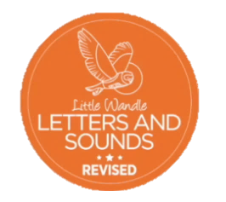
Phase 4 – Summer 2 Week 4
Focus – words ending in -ing, -ed.
Please support your child to practise and reinforce the phonemes and graphemes we are learning in school. More information and support can be found on the Little Wandle website - https://www.littlewandlelettersandsounds.org.uk/resources/for-parents/

We will be reading words ending in -ing and -ed. Can you spot the different sound the ed makes? (/t/,/id/,/d/)
groaning sleeping crowding painting
cloaked sparked screeched splashed
crowded floated boasted painted
speared crowned cleared stormed

We will be practising tricky words. Can you spot the tricky part of the word?
the I go no you
said so have like

Can you sort the words in to the sound ed makes? (One has been done for you)

/t/- sparked | /id/ - crowded | /d/- speared

toasted scooped groaned started croaked smeared
We will be reading sentences. Can you spot any tricky words?
I said, “I like toasted buns do you?”
When I am painting I do not like to get splashed.
He screeched at the mud smeared on his coat.

