 | Little Wandle - Letters and Sounds  EYFS Phonics Home Learning | 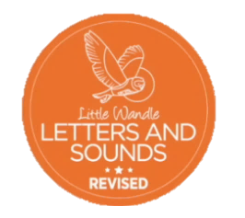
Phase 4 – Summer 1 Week 4
Focus – longer words and compound words
Please support your child to practise and reinforce the phonemes and graphemes we are learning in school. More information and support can be found on the Little Wandle website - https://www.littlewandlelettersandsounds.org.uk/resources/for-parents/

We will be reading longer words and compound words. Can you chunk up the words to help you read them?
tantrum(tan/trum) forest(fo/rest) printer chapter blanket(blank/et) blossom(bloss/om) shampoo(sham/poo) children(child/ren) chimpanzee(chim/pan/zee) windmill(wind/mill) sandpit(sand/pit) handstand(hand/stand)
We will be practising tricky words. Can you spot the tricky part of the word?
there when what one
Can you match the words and pictures?

blanket shampoo present chimpanzee

We will be reading sentences. Can you spot any tricky words?
We are strong and we sprint in the forest.
The shampoo smells of blossom.
The chimpanzee did a handstand on his present.

