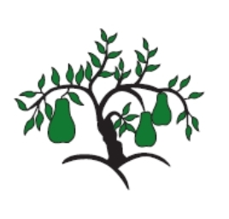 | Little Wandle - Letters and Sounds  EYFS Phonics Home Learning | 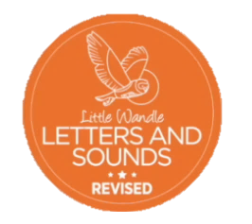
Phase 4 – Summer 1 Week 3
Focus – CCVCC, CCCVC and CCCVCC words
Please support your child to practise and reinforce the phonemes and graphemes we are learning in school. More information and support can be found on the Little Wandle website - https://www.littlewandlelettersandsounds.org.uk/resources/for-parents/

We will be reading CCVCC, CCCVC and CCCVCC words
stamp spend crept twist trust swift crisp blend crunch crust grand squelch
string scrap splat strap scrub strong
script scrunch strand strict sprint

We will be practising tricky words. Can you spot the tricky part of the word?
were here little says

Can you match the words and pictures?

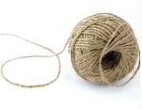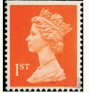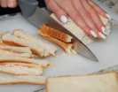

stamp bench string crust

We will be reading sentences. Can you spot any tricky words?
It is fun to stamp and twist to the drums.
My boots went squelch in the mud.
The string was strong and held up the shelf.

