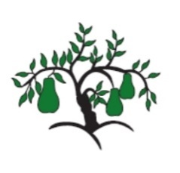 | Little Wandle  EYFS Phonics Home Learning | 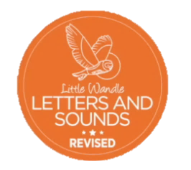
Phase 3 – Spring 2 Week 3
Focus – words with two or more diagraphs
Please support your child to practise and reinforce the phonemes and graphemes we are learning in school. More information and support can be found on the Little Wandle website - https://www.littlewandlelettersandsounds.org.uk/resources/for-parents/
Phonemes we will be focusing on this week in school –
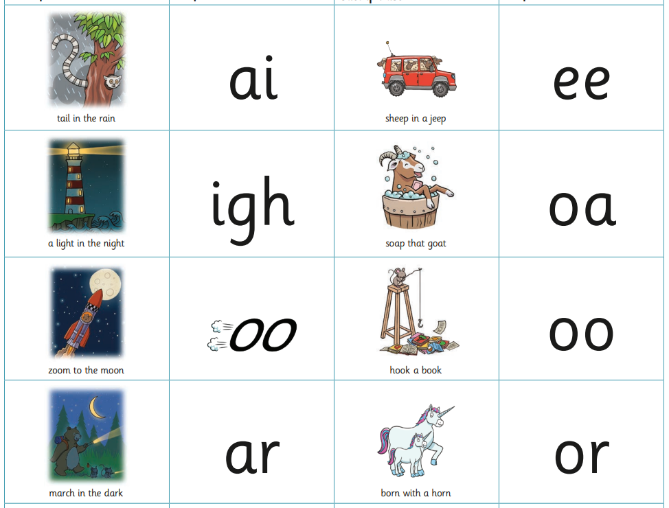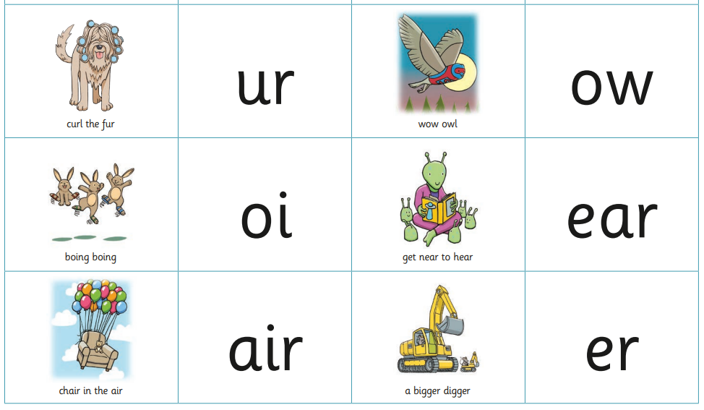

We have been reading and writing longer words. Can you spot the digraphs?
sharp shark sheep cheep queen tooth short thinker powder church corner farmer torch chain shower march

We have been reading sentences. Can you spot any tricky words?
The sheep march up the hill and into the sunset.
We tell the farmer that his goat has got inti the shower.

We have been practising tricky words. Can you spot the tricky part of the word?
no of to into she he we

