TARPORLEY CE
PRIMARY SCHOOL
Let Your Light Shine (Matthew 5)
Tarporley Church of England Primary School is a welcoming and friendly Church school that provides high quality education for children aged 5-11. As a Church school we hold our Christian Values at the heart of everything we do. These are: LOVE, FRIENDSHIP, TRUST, HOPE, FORGIVENESS, JOY & CELEBRATION
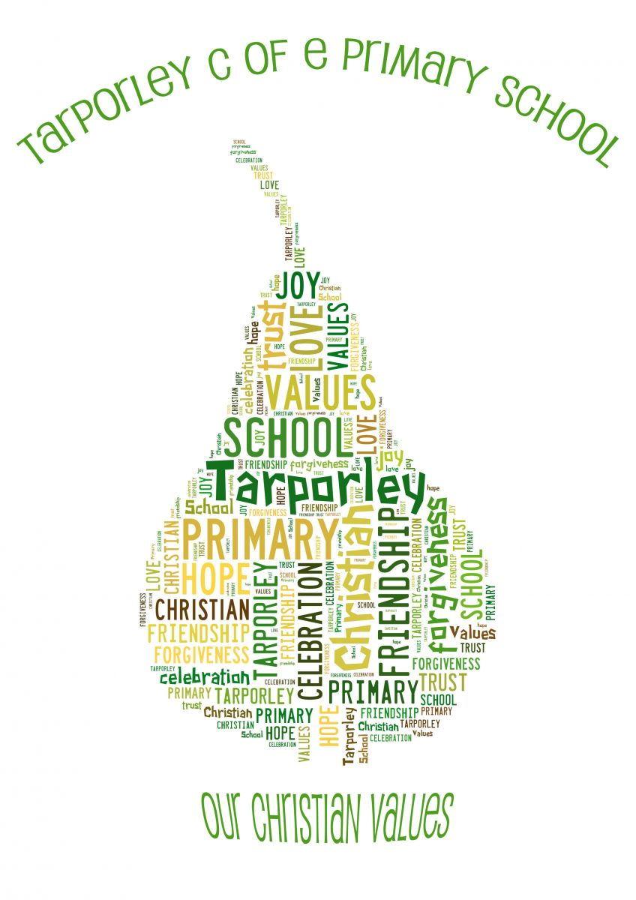
It is very important to us that the children are happy and experience the best education possible. We value strong links and a close partnership between home, church and school and recognise the importance of trust and shared responsibility in education.

Transition Policy

Transition Policy
The overall responsibility for transition lies with the Head Teacher. It may be delegated to Key Stage Leaders and individual class teachers. The Head Teacher will provide the necessary resources for the maintenance and development of this policy including opportunities for staff to share information and data. This also includes time for the EYFS teacher to visit preschool settings. The SLT (Senior Leadership Team) will evaluate the transition processes and update or change procedures as necessary.
Equal Opportunities
We recognise that for some children e.g. special educational needs, looked after children, English as an additional language, transition may be a stressful period of time that can affect their progress. As an inclusive school that welcomes children from all backgrounds and abilities, we will ensure to identify those requiring special attention/support.
PRINCIPLES THAT UNDERPIN THE POLICY
- Approaches to teaching and learning should be co-ordinated to ensure effective transition.
- Styles of teaching and learning should meet the needs of the children.
- Assessment data should be shared and used for planning in the autumn term.
- There should be a professional regard for the information from the previous class, setting or phase.
- Transition should motivate and challenge children.
- Transition should ensure that children feel secure and safe in their new environment.
- Staff allocation gives particular attention to the particular needs of the children.
- School will work closely with parents of LAC/Post LAC/SEND pupils so they have the tools to be able to support their children through the transition process.

EYFS – Starting school
At Tarporley CE Primary School we want our children to experience a smooth transition from one setting to the next, so that pace and quality of learning are maintained to ensure that children continue to make good progress. We recognise that starting school is a big step for every child and aim to make sure every child is prepared for the big day.
We work closely with a range of feeder pre-schools to get to know the children who will be starting at our school.
Our close links with the Done Room pre-school in Tarporley mean that children will have visited our school or met the class teacher at the pre-school on numerous occasions before the formal transition process begins in the summer term. This allows for a smooth transition to school.
In the summer term we start with a Parents Evening Talk with an opportunity for members of the school community to meet and chat with parents and answer any questions. A ‘Starter Pack’ is provided with lots of details about September and the Reception class such as:
- Stay and Play dates for parents and children.
- Visits to the pre-school setting.
Each child is allocated and a Year 6 buddy who will help them in September
Please see our Frequently Asked Questions document. Appendix 1

Transition Between Year Groups
Once children have been allocated their class (see appendix 2) the following arrangements are put into place by the class teacher:
- Transition meetings take place between the class teachers and SENDCO if appropriate.
- Children spend an afternoon in their new class with their new teacher and class mates.
- Class talk for parents in September – an opportunity for parents to meet the class teacher and gather information for the coming year.
Transition from Y6 to Y7
Applications for secondary places are made through CWAC admissions. Further details can be found on the following website https://www.cheshirewestandchester.gov.uk/residents/education-and-learning/school-admissions/school-admissions.aspx
- Parents are encouraged to attend Open Evenings for the secondary schools that they may be considering for their child. Details are forwarded via the school email service regarding transition events for Tarporley High School.
- At the end of the Summer Term the Y5 children attend their first transition day at Tarporley High School.
- Additional transition visits and activities to Tarporley High School are carried out throughout Year 6.
- Once places have been allocated the SENDCO from the receiving High School meets with our SENDCO and class teacher to discuss those children with additional needs and arrange any extra visits if required.
- Tarporley High School currently request information to help them establish tutor groups. This is based on who children work best with, their effort, ability and any additional information deemed relevant.
- Children with specific medical or educational needs records are prepared and sent by the SENDco / Admin Officer to the receiving High School.
- Safeguarding records are shared with receiving High School.
Consideration Made for Allocation of Tutor Groups
All children in year 6 who are moving on to Tarporley High School are given the opportunity to express their preference regarding who they are grouped with.
During the school year the following process will be implemented as far as is reasonably possible:
- Children are asked to provide a list of up to 5 named children from the year 6 cohort who they feel they work best with and would be happy to be in a tutor group with.
- A letter is sent home for the children to complete this list with parents.
- The Headteacher will then allocate as evenly as possible the children into groupings guaranteeing at least 1 child from the lists provided.
- When grouping, consideration will be given to additional needs, learning styles, any existing behaviour issues.
- This information will then be passed on to Tarporley High School for final tutor group allocation and band setting. Band setting is allocated by Tarporley High School.
- Tutor group allocation will be announced by Tarporley High School.

For those children attending any other High School the procedures requested will be followed.
For children joining the school at any other point please see our ‘Pupil Induction Policy’
Reviewed May 2022

Appendix 1 New Starter Frequently Asked Questions

Why do the children need to start with half days as my child attended nursery full time?
We have chosen to start the children’s schooling with half days; morning sessions or afternoon sessions. This is an important time as staff can spend quality time with the children in a smaller group. We can focus on their individual needs and introduce them to aspects of our routine, such as assemblies and play times, slowly and with adult support. Even if they attended a nursery or preschool full time they will find school very tiring and half days should ease the children into the changes.
Why can’t my child choose which children they attend the half day sessions with?
We are committed to keeping the morning and afternoon groups as evenly numbered as possible to enable staff the opportunity to get to know each of the children adequately before the children begin attending full time. We spilt the groups based on the register!
What activities are the children doing in the half days?
During the half days at the beginning of the year, the children will spend lots of time getting to know the areas of the classroom by playing. We also do craft activities, their first PE session and even some cooking!
What does my child need to bring to school each day?
Your child will need to bring their book bag every day. As they progress over the year, their book bag will also have reading books, a reading record. They also need to bring a water bottle and weather appropriate clothing. They can leave spare clothes and underwear in school. They can also leave a pair of wellies in school.
Can I choose which school house my child is in?
Children with siblings or other relations in school will be placed in the same house as the other members of their family. Children who are new to the school will be carefully placed in houses ensuring that the overall totals remain equal.
What if my child doesn’t like their school dinner?
The three weekly menu is on our school website. Children are asked to choose their lunch from the options available on the day. The class teacher or teaching assistant is in the dinner hall with the children every day and quickly become familiar with their preferences. We encourage but will never force children to eat food.
What happens if my child cannot cut up their food?
The class teacher, TA or mid-day assistants are available to help the children cut their food. As the year progresses we encourage the children to cut their own food (soft foods first). We always help the children cut some items such as meat and jacket potatoes.

What happens if my child is sick?
You must inform the school office on the first day of absence. If your child has vomited or experienced an episode of diarrhoea, then you must keep your child at home for a 48hr period following the last bout of sickness or diarrhoea.
What time does school start and finish?
The school day starts promptly at 8.45am and ends at 3.20pm.
What happens if I need before and after school care?
Treehouse before and after school club can meet all your needs. More details are on the school website http://www.tarporleyce.cheshire.sch.uk/page/after-school-club/2613

Appendix 2
Information regarding mixed age classes and split year groups

What is a mixed age and split year group class?

A mixed age class is defined to be a class in which there are children who are from
more than one-year group of the primary school.

Why are mixed age and split year group classes formed?

Mixed age classes are formed in most schools partly because of the way in which the
pupil roll is configured in any given year (i.e. the number of pupils in each year group).
It is not uncommon for this situation to change from year to year, as the class sizes
can vary quite dramatically.

Will my child be held back if placed in a mixed age or split year group class?

No. The ways in which learning and teaching are organised in primary schools means
that teaching and work is tailored to the needs and current achievement levels of
individual pupils. Teachers provide challenge for the more able children and support for
those needing more help, whichever year group they are currently in.

Why is the situation different in this school from that in others?

Different situations pertain in all schools. The overwhelming majority of primary
schools in Cheshire West and Chester, that have formed mixed age classes, show
there is no evidence to suggest that being in a mixed age class has any detrimental
effect whatsoever on the education of children in that class.

I am concerned that forming a mixed age or split class may mean my child’s
friendship grouping is being broken up.

Although care is taken in allocation of pupils to classes, their social needs are not
ignored. There are many opportunities for pupils to maintain contact with friends who
have been allocated to other classes, such as lunchtimes, playtimes, special activities,
trips and school performances. When children transfer to secondary school, new
friendship groupings in different subject areas become a fact of life, and this situation is
generally welcomed by many children.

If a mixed age or split year class is formed, how are decisions taken about which
children should be allocated to which class?

We take a number of influences into consideration and make a professional judgment
based on this. Split year groups are considered very carefully, depending on each
cohort of children. The main considerations are:

- age and gender (balance of class and year group)
- additional needs
- social learning group

All these factors will be taken into consideration by the headteacher and class teachers
when making a decision. Parents are informed about the new organisation and
opportunities are available for any family wishing to discuss their child’s learning.
However, it is the headteacher who makes the final allocation based on their
professional judgement of where the child will best flourish in both their personal, social
and academic achievements.

