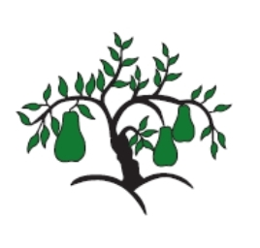 | Little Wandle - Letters and Sounds  EYFS Phonics Home Learning | 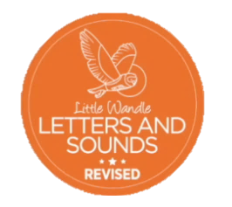
Phase 3 – Spring 2 Week 5
Focus – longer words / words ending in -(s/z) - es
Please support your child to practise and reinforce the phonemes and graphemes we are learning in school. More information and support can be found on the Little Wandle website - https://www.littlewandlelettersandsounds.org.uk/resources/for-parents/
Phonemes we will be focusing on this week in school –
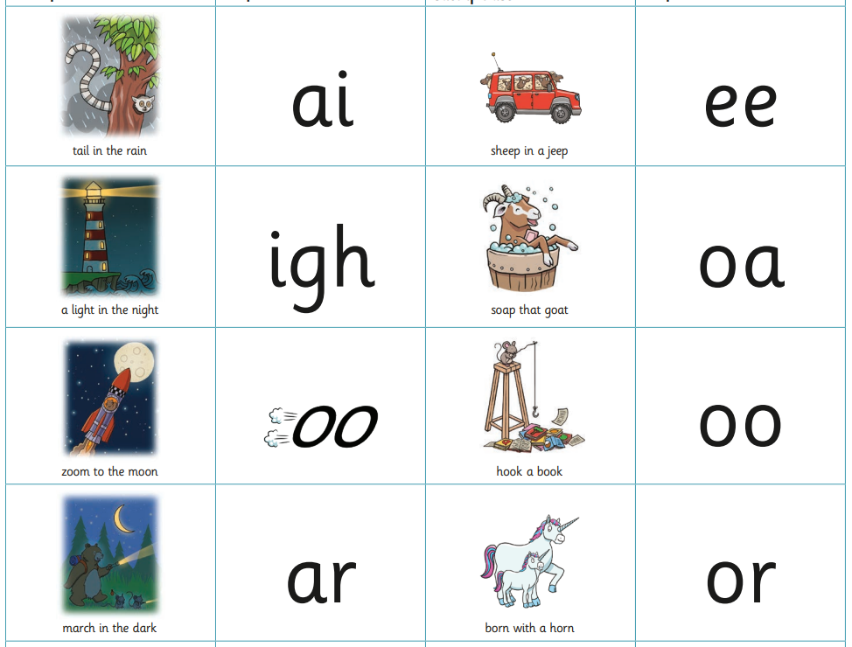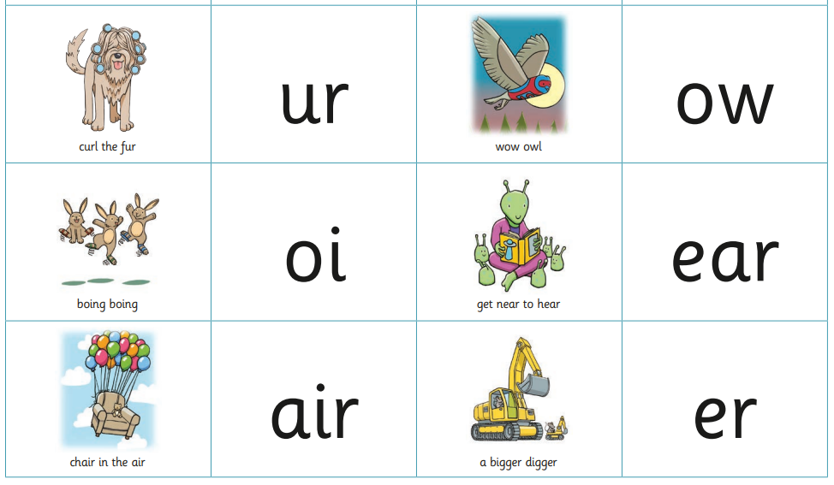

We will be reading and writing longer words. Can you spot this weeks phonemes?
lightning mammoth earring poison
queens chains chairs cars
boots surfs cooks cheeps
torches boxes fizzes fishes

We will be reading sentences. Can you spot any tricky words?
You need to put on coats and boots to go into the garden.
The cooks pop the popcorn and pop it into boxes!

We will be practising tricky words. Can you spot the tricky part of the word?
they all by my are sure pure

