TARPORLEY CE PRIMARY SCHOOL
Let Your Light Shine (Matthew 5)

Tarporley Church of England Primary School is a welcoming and friendly Church school that provides high quality education for children aged 5-11. As a Church school we hold our Christian Values at the heart of everything we do. These are: LOVE, FRIENDSHIP, TRUST, HOPE, FORGIVENESS, JOY & CELEBRATION
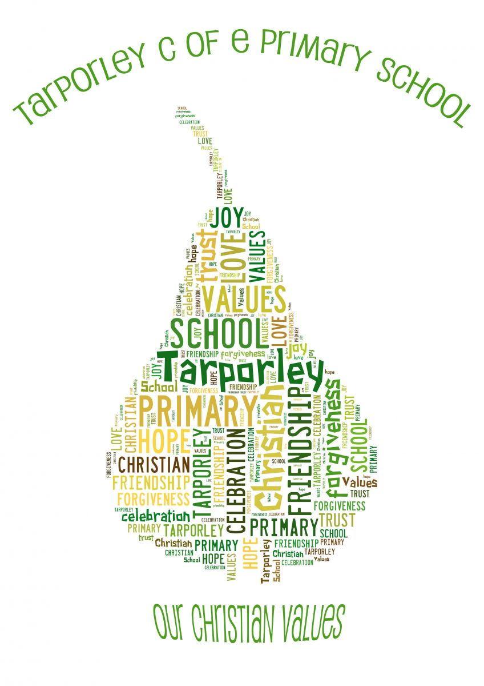
It is very important to us that the children are happy and experience the best education possible. We value strong links and a close partnership between home, church and school and recognise the importance of trust and shared responsibility in education.

Art and Design Policy

Art and Design

Arts and culture inspire and excite. They enable all children to look at the world differently with awe and wonder. Our vision at Tarporley CE Primary is for every adult and child to ‘Let Your Light Shine’ and arts learning is very much part of what drive us. With our Christian values at our core, we nurture a love of learning and inspire everyone to let their light shine and to encourage our children to be the best they can be in all aspects of school life and to embrace opportunities throughout.

Art and Design activities enrich children’s learning and enable them to communicate their thoughts, ideas and observations in a practical and expressive way. Through our BOOKS curriculum, we have developed an art curriculum to nurture children to become creative thinkers that are outward-facing and reach their full potential through the development of knowledge, self-esteem and confidence. Our aim is for children to experience a stimulating and balanced curriculum that shows progression and continuity of skills. We want our children to be able to recognise their talents as writers, artists, musicians and performers and to express themselves freely and innovatively and seek opportunities to take their learning further. A high-quality art and design education will engage, inspire and challenge pupils, equipping them with the knowledge and skills to experiment, invest and create their own works of art, craft and design. In talking about art and evaluating their own and others’ work, children are encouraged to develop their visual language, ideas and feelings. Through experience of a variety of materials, tools and techniques, children have the opportunity to experience and record the world around them in a creative way. They should also develop an understanding and appreciation of how art and design reflects and shapes our history, and how it contributes to our culture, creativity and wealth of our nation.

Intent
Arts and culture inspire and excite. They enable all children to look at the world differently with awe and wonder. Our vision at Tarporley CE Primary is for every adult and child to ‘Let Your Light Shine’ and arts learning is very much part of what drive us. With our Christian values at our core, we nurture a love of learning and inspire everyone to let their light shine and to encourage our children to be the best they can be in all aspects of school life and to embrace opportunities throughout.
We believe that art is a process that involves not only learning and progressing skills and techniques, but also taking risks and experimenting. Our children have the opportunity to try new things, experiment with their ideas, express themselves and find their own sense of style. Through our BOOKS curriculum, we have developed an art curriculum to nurture children to become creative thinkers that are outward-facing and reach their full potential through the development of knowledge, self-esteem and confidence. Our aim is for children to experience a stimulating and balanced curriculum that shows progression and continuity of skills. We want our children to be able to recognise their talents as writers, artists, musicians and performers and to express themselves freely and innovatively and seek opportunities to take their learning further. A high-quality art and design education will engage, inspire and challenge pupils, equipping them with the knowledge and skills to experiment, invest and create their own works of art, craft and design.
Our children use all they have learnt and are inspired to make imaginative, creative and individual pieces of art. They:
- are given the opportunity to experience and experiment with a wide range of media
- learn and develop a variety of artistic skills and techniques
- are able to understand and appreciate art, craft and design, where it comes from, who makes it and how it is made
- are able to describe their own work, and the work of others, using appropriate vocabulary
- make reasoned choices about the materials and techniques they will use
- are able to evaluate their own work and the work of others stating their preferences and the reasoning behind them

Implementation
At Tarporley CE Primary, we believe a high-quality art and design education should engage, inspire and challenge pupils, equipping them with the knowledge and skills to experiment, invent and create their own works of art, craft and design. As pupils progress, they should be able to think critically and develop a more rigorous understanding of art and design. To do this we follow the National Curriculum but use the Accessart curriculum as the basis for planning our teaching and learning in art, ensuring that our children's learning of skills and techniques is progressive and builds on their prior learning and experience. Children have lessons in which they experience and learn the skills, crafts and techniques of art in the key mediums: drawing, painting and sculpture, as well as learning skills through malleable materials, collage, textiles, and printing. Children from KS1 onwards have opportunities to explore and investigate tools and techniques and to develop their skills and ideas in sketchbooks. Where possible, the stimulus for our art teaching is linked to other areas of the curriculum to make it more meaningful and to help the children deepen their learning and make cross-curricular links. Within each pathway of art, children learn about artists and crafts people, their work and their influence, some known worldwide and some lesser-known. We have carefully moulded our curriculum so children at Tarporley will know how art and design both reflect and shape our history, and contribute to the culture, creativity and wealth of our nation. They will understand that art is a subjective subject; when we look at a piece of art, we will have an emotional response to it and we can learn to appreciate different forms of art and learn from the artist. We make sure we provide opportunities for our children to discuss and appreciate a range of artwork including those of their peers.
Art and Design at Tarporley CE Primary is a process that involves not only learning and progressing skills and techniques, but also taking risks and experimenting. Our children have the opportunity to try new things, experiment with their ideas, express themselves and find their own sense of style. Art is not only confined to lessons, it is also used by the children in other areas of the curriculum and embedded through whole school themed art projects, art and craft clubs and engagement with the local community through projects and local artists.
Our curriculum ensures:
- High quality, purposeful lessons are planned collaboratively to include and enhance all areas of the wider curriculum
- Skills and knowledge are built, developed and practiced year on year with progression evident in sketch books, wider work and displays
- Children’s learning is supported by the use of a wide range of resources
- Children create mixture of individual, small group and class pieces
- Engagement with the local community through collaborative events and the display of children’s work in community spaces such as church and local art galleries.
- Children have the opportunity to engage in the Arts Award programme.

Impact- how do we know our Art curriculum is effective?
We want children to leave Tarporley CE Primary with a knowledgeable skillset in art, the resilience to be brave and take risks with their own learning where mistakes are seen as part of life. Most importantly, we want our children to leave Tarporley CE Primary with a passion in the arts and ready to continue their journey of self-expression and creativity.
To judge whether this has been successfully achieved the following monitoring will be undertaken by the Art and Design Subject Leader:
- review of the scheme of work
- pupil voice every term
- sketchbook looks with pupils
- a variety of sketchbooks and final pieces of artwork will be photographed from each Key Stage
- majority of artwork will be displayed and celebrated around the school
- Teachers will discuss and review individual evidence of children’s work to ensure the expected level of achievement in art and design for each Key Stage. This will be shared with the Subject Leader.
EYFS
Art and Design in EYFS is promoted as open-ended creative learning, placing emphasis on the creative journey and nurturing children to become confidence and independent creators. In order to prepare children for the art curriculum in Key Stage 1 and 2, children will be given opportunities and experiences which enable pupils to:
- Build dexterity skills
- Explore materials and mark making in a playful way
- Use bodies and imaginations to inspire making
- Explore how they can reflect and share their views about what they have seen or made
- Explore how art enriches our lives
EYFS teachers will work closely with the Art Subject Leader to choose activities and experiences which fit in with theme-based learning and the objectives set out in the Early Learning Goals.
Pupil Voice
Pupil voice is used to not only assess children's knowledge of what they have been taught, but to also highlight children’s thought and feelings about art as a subject, their own artwork and other's.
Displays
We believe Art is created to be celebrated and enjoyed. The majority of the displays in school will celebrate our children's artwork and learning.
SEND Provision in Art
Art and Tarporley CE Primary wholeheartedly centres around children being able to express themselves creatively. Regardless of background or vulnerability, our children are given all they need to grow, flourish and 'Let their Light shine'. The outcome for each pathway of art centres around an individuals response and their creativity and individual thought is encouraged and celebrated. We want to ensure every child at Tarporley can enjoy art and produce artwork they are proud of. We ensure every child learns at their own level and can progress with the support of teacher feedback in class. Sketchbooks are seen as journals where each individual can show their development, explore and practise different techniques and materials and most importantly, express themselves. We ensure that teaching is sensitively adapted and processes are transformed for every child to explore their creative potential.
Sketchbooks
Sketchbooks are used to explore ideas, practise techniques and for children to record their unique responses and express their creativity. Sketchbooks start in Year 1 and are passed on from year to year. We believe they showcase a substantial measure of progress as each child's sketchbook acts a visual journal showing clear skill and knowledge development.

As a school, we follow the guidance of the Code of Practice for Special Educational Needs and this may have implications for the teaching of this subject.

Art is a foundation subject in the NC. Planning is in line with NC requirements for Key Stage 1 and Key Stage 2 and the Early Years Foundation Stage curriculum. The Senior Leadership Team and the subject lead for Art and Design will monitor and review coverage in line with the content specified in the NC.

Our art and design curriculum, where appropriate and meaningful, will link with our termly themes. This enables pupils to explore concepts in greater depth and to make links in their learning across different curriculum areas. Our curriculum can be found on the Curriculum tab on our school website.

Early Years Foundation Stage
Art and Design in EYFS will be promoted as open-ended creative learning, that placing emphasis on the creative journey and nurturing children to become confidence and independent creators. In order to prepare children for the art curriculum in Key Stage 1 and 2, children will be given opportunities and experiences which enable pupils to:

- Build dexterity skills
- Explore materials and mark making in a playful way
- Use bodies and imaginations to inspire making
- Explore how they can reflect and share their views about what they have seen or made
- Explore how art enriches our lives

EYFS teachers will choose activities and experiences which fit in with theme-based learning and the objectives set out in the Early Learning Goals.

Contribution of art and design to teaching and learning in other curriculum areas

English
Art and design contribute to the teaching of English in our school by developing children’s vocabulary so they can express their thoughts and feelings about artwork/artists. We also encourage children to ask and answer questions about the starting points for their work. This will be done at the start of every pathway with a talking point discussion with children as a way to introduce a new artist or art medium. Children will also have the opportunity to compare ideas, methods and approaches in their own work and that of other children, and to say what they think and feel about them.

Mathematics
Art and design contributes to the teaching of mathematics in our school by giving opportunities to develop the children’s understanding of shape and space through work in two and three dimensions.

Spiritual, moral, social and cultural development
The teaching of art and design offers opportunities to support the social development of our children through the way we expect them to work with each other in lessons. Groupings allow children to work together and give them the chance to discuss their ideas and feelings about their own work and the work of others. Their work in general helps them to develop a respect for the abilities of other children and encourages them to collaborate and co-operate across a range of activities and experiences. The children learn to respect and work with each other and with adults, thus developing a better understanding of themselves. They also develop an understanding of different times and cultures through their work on famous artists, designers and craftspeople.

Inclusion

At Tarporley CE, we plan to provide for all pupils to achieve, including boys and girls, higher achieving pupils, gifted and talented pupils, those with SEND, pupils from all social and cultural backgrounds, children who are in care and those subject to safeguarding, pupils from different ethnic groups and those from diverse linguistic backgrounds.

Resources

We have a wide range of resources to support the teaching of art and design across the school. All our classrooms have a range of basic resources, but we keep the more specialised equipment in the art cupboards.

Assessment and Monitoring

Details regarding how we assess Art and Design can be found in the school’s Assessment Policy.

The art subject lead will monitor the teaching of art half termly through pupil voice, sketchbook looks and pupil interviews with Key Stage art ambassadors. The art subject leader will photograph pieces of art and the majority of artwork will be displayed and celebrated around the school. Teachers will also share the process behind the artwork and finished pieces on Twitter. Teachers discuss and review individual evidence of children’s work to ensure teachers are clear about the expected level of achievement in art and design for each Key Stage.

Health and Safety

Teachers should ensure that all learning takes place within a safe environment with special reference to the use of materials, equipment, tools and artefacts.

Children should be supervised at all times and any classroom helpers should be familiarised with safe practices.

Protective clothing should be worn where appropriate.

Children will require specific training to use potentially dangerous tools and equipment in a safe way. The best way to achieve this is by clear, confident demonstrations, positive guidance and supervision.

Craft knives are extremely dangerous and should only be used by staff.

Sharp pointed scissors are only to be used by responsible older children under the direct supervision of the teacher.

The use of glue guns is outlined in the Design and Technology policy.

Reviewed: Spring 2024

Review date: Spring 2027

