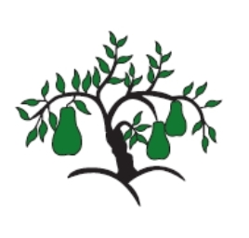 | Little Wandle - Letters and Sounds  EYFS Phonics Home Learning | 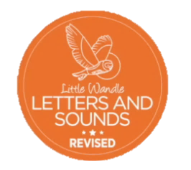
 | Phase 3 – Spring 1 Week 5
Please support your child to practise and reinforce the phonemes and graphemes we are learning in school. More information and support can be found on the Little Wandle website - https://www.littlewandlelettersandsounds.org.uk/resources/for-parents/
Phonemes we will be focusing on this week in school –
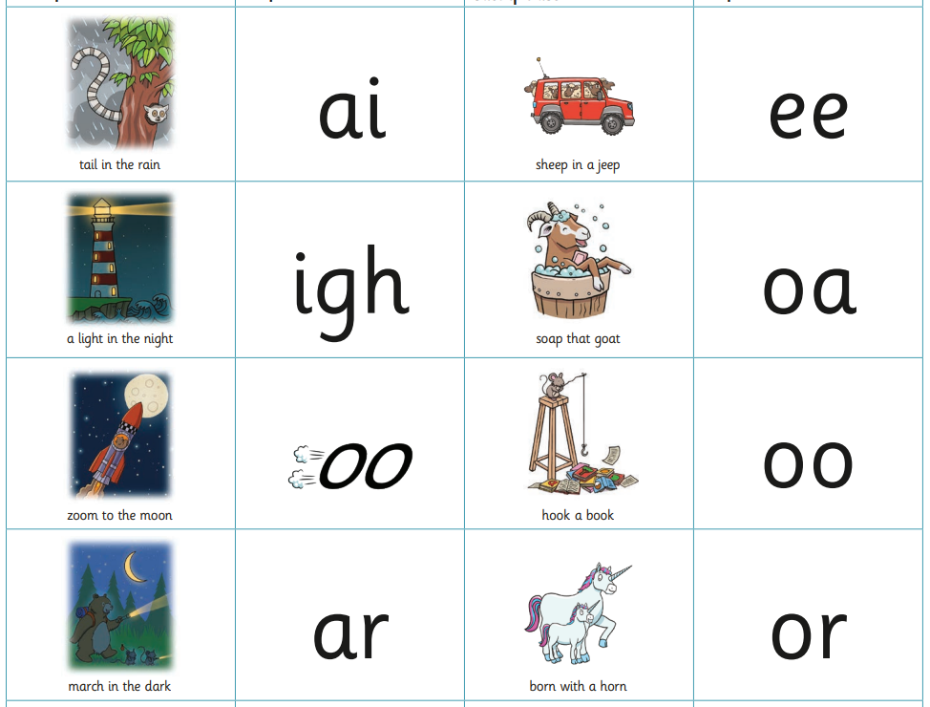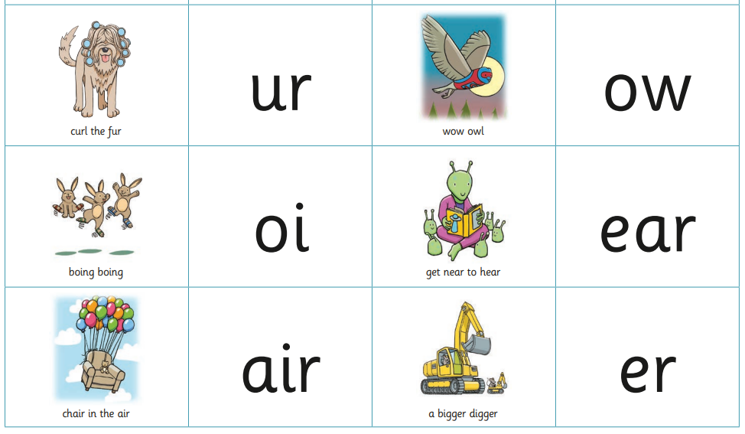

We will be reading and writing compound words and words with two syllables.
laptop popcorn raincoat starfish

sunset market ticket melon

We will be reading sentences. Can you spot any tricky words?
We had a picnic at sunset.
He has a chicken in his pocket.
The goat was in the farmyard.
I can see a starfish.

We will be practising tricky words. Can you spot the tricky part of the word?
are sure pure into

she he we me be of

