 | Little Wandle - Letters and Sounds  EYFS Phonics Home Learning | 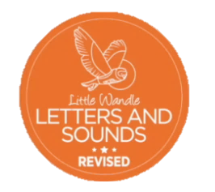
 | Phase 3 – Spring 1 Week 4
Please support your child to practise and reinforce the phonemes and graphemes we are learning in school. More information and support can be found on the Little Wandle website - https://www.littlewandlelettersandsounds.org.uk/resources/for-parents/
Phonemes we will be focusing on this week in school –
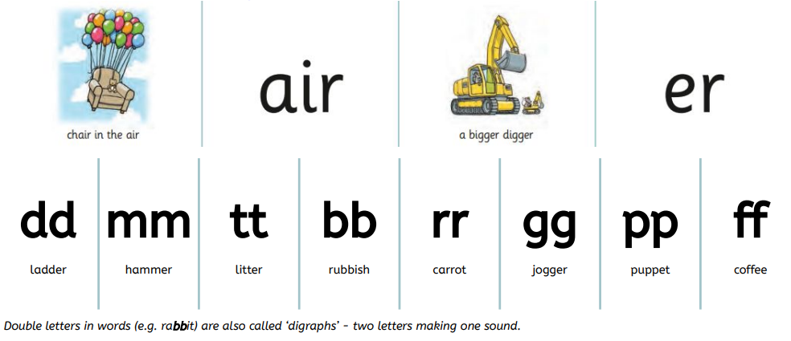

We will be reading and writing words. Can you spot this week’s phonemes?
hair boxer letter rubber chair summer rubbish coffee

We will be reading sentences. Can you spot any tricky words?
The man has no hair.
He hits the nail with a hammer.
The rabbit needs a bigger carrot.
We get a letter from the queen.

We will be practising tricky words. Can you spot the tricky part of the word?
my by all no go are sure pure

