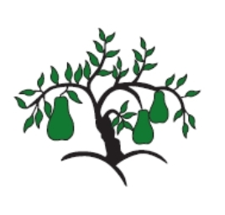 | Little Wandle - Letters and Sounds  EYFS Phonics Home Learning | 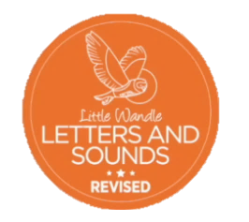
 | Phase 3 – Spring 1 Week 3
Please support your child to practise and reinforce the phonemes and graphemes we are learning in school. More information and support can be found on the Little Wandle website - https://www.littlewandlelettersandsounds.org.uk/resources/for-parents/
Phonemes we will be focusing on this week in school –
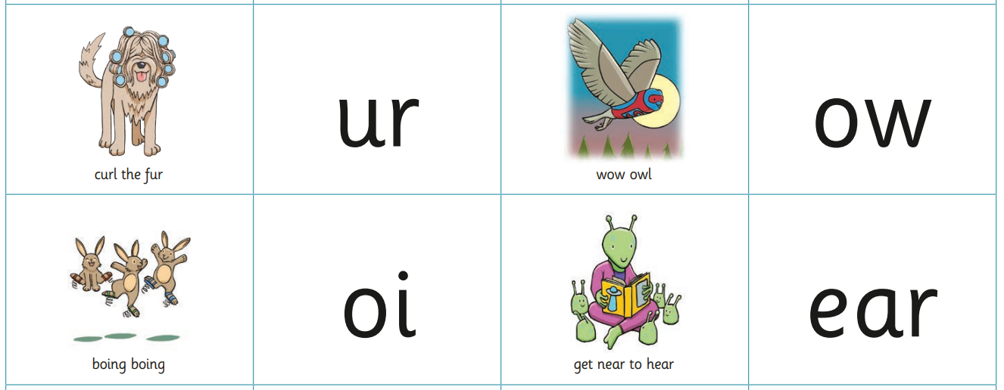

We will be reading and writing words. Can you spot this week’s phonemes?
surf howl oil hear
turn down join tear

We will be reading sentences. Can you spot any tricky words?
The pig has a curl in his tail. We go to the shop in town.

He boils the food in the pan. I can hear the owl hoot.

We will be practising tricky words. Can you spot the tricky part of the word?
was you they into

my by all

