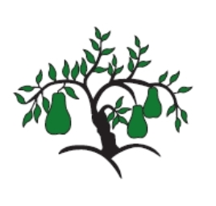 | Little Wandle - Letters and Sounds  EYFS Phonics Home Learning | 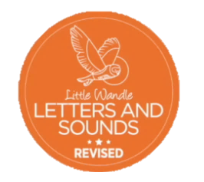
 | Phase 3 – Spring 1 Week 2
Please support your child to practise and reinforce the phonemes and graphemes we are learning in school. More information and support can be found on the Little Wandle website - https://www.littlewandlelettersandsounds.org.uk/resources/for-parents/
Phonemes we will be focusing on this week in school –
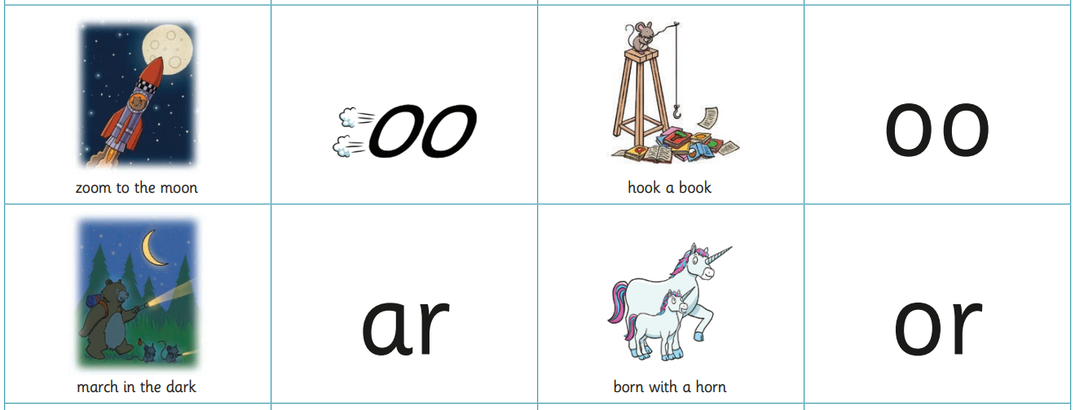

We will be reading and writing words. Can you spot this week’s phonemes?
zoo good bark pork

room hook yard born

We will be reading sentences. Can you spot any tricky words?
His food is not hot. The got has sharp horns.

The car has lights on in the dark. I look at the moon.

We will be practising tricky words. Can you spot the tricky part of the word?
was you they

