 | Little Wandle - Letters and Sounds  EYFS Phonics Home Learning | 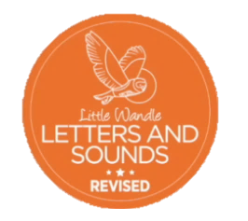
 | Phase 3 – Spring 1 Week 1
Please support your child to practise and reinforce the phonemes and graphemes we are learning in school. More information and support can be found on the Little Wandle website - https://www.littlewandlelettersandsounds.org.uk/resources/for-parents/
Phonemes we will be focusing on this week in school –
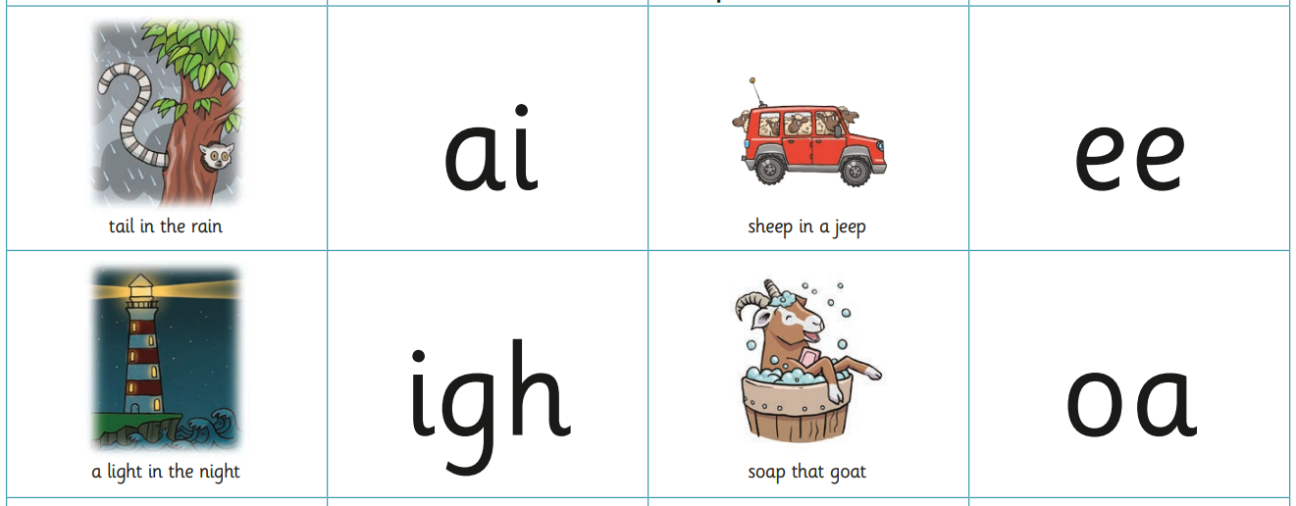

We will be reading and writing words. Can you spot this week’s phonemes?
pain see sight coat
hail jeep high road

We will be reading sentences. Can you spot any tricky words?
The cat has a tail. His feet go deep in the mud.

I can see a bat at night. The goat had a red coat.

We will be practising tricky words. Can you spot the tricky part of the word?
is as the I

