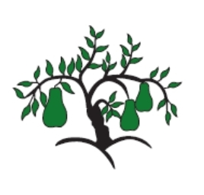 | Little Wandle - Letters and Sounds  EYFS Phonics Home Learning | 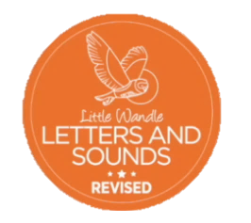
 | Phase 2 – Autumn 2 Week 5
Please support your child to practise and reinforce the phonemes and graphemes we are learning in school. More information and support can be found on the Little Wandle website - https://www.littlewandlelettersandsounds.org.uk/resources/for-parents/
In school we will be reviewing all the phonemes we have learnt so far–
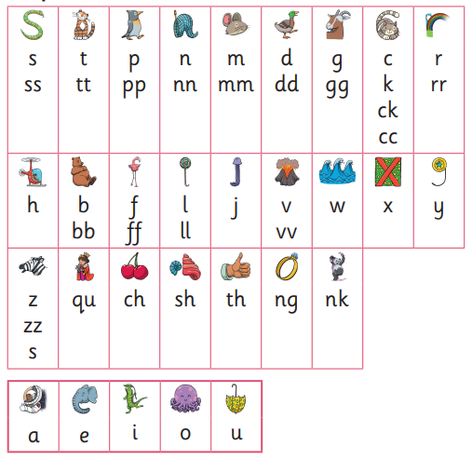

We will be reading and writing words with ‘s’ at the end.
ducks ships shuts rings shells sings

We will be reading short phases. Can you spot any tricky words?
She has six ducks. He has pink shells.

His cats get on the bed to nap.

We will be reviewing these tricky words. Can you spot the tricky part of the word?
the put pull full I and go no to into be we me she push he her

