 | Little Wandle - Letters and Sounds  EYFS Phonics Home Learning | 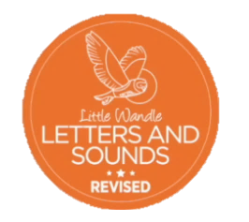
 | Phase 2 – Autumn 2 Week 3
Please support your child to practise and reinforce the phonemes and graphemes we are learning in school. More information and support can be found on the Little Wandle website - https://www.littlewandlelettersandsounds.org.uk/resources/for-parents/
Phonemes we will be focusing on this week in school –
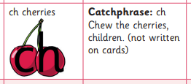

We will be reading and writing these words. Can you spot this week’s phonemes?
zip quick chip zap chop quack buzz rich quit

Read each sentence and circle any tricky words.

A cat on a bed.

Run to the log hut.

No lid on the pan.

Jump into the mud

Can I go to the pond?

We will be practising tricky words. Can you spot the tricky part of the word?

and has his her go no to into

