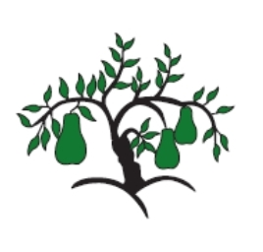 | Little Wandle - Letters and Sounds  EYFS Phonics Home Learning | 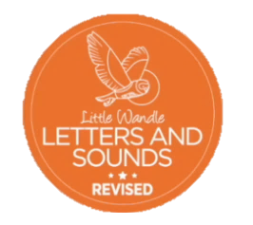
 | Phase 2 – Autumn 1 Week 5
Please support your child to practise and reinforce the phonemes and graphemes we are learning in school. More information and support can be found on the Little Wandle website - https://www.littlewandlelettersandsounds.org.uk/resources/for-parents/
Phonemes we will be focusing on this week in school –
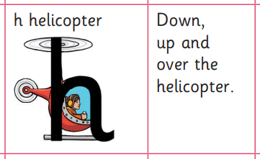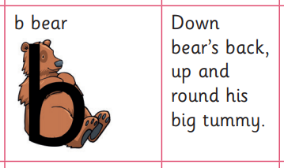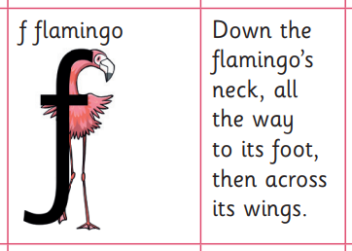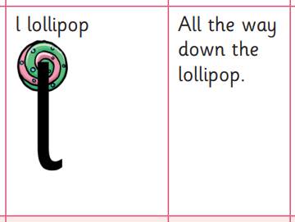

We will be learning to recognise the graphemes and not including a schwar (E.g. fuh, luh)

We will be reading and writing words. Can you spot this week’s phonemes?

hug big fat luck

bed muck kid rub

Can you write the initial sound for these pictures?
