TARPORLEY CE PRIMARY SCHOOL
Tarporley Church of England Primary School is a welcoming and friendly Church school that provides high quality education for children aged 5-11. As a Church school we hold our Christian Values at the heart of everything we do. These are: LOVE, FRIENDSHIP, TRUST, HOPE, FORGIVENESS, JOY & CELEBRATION
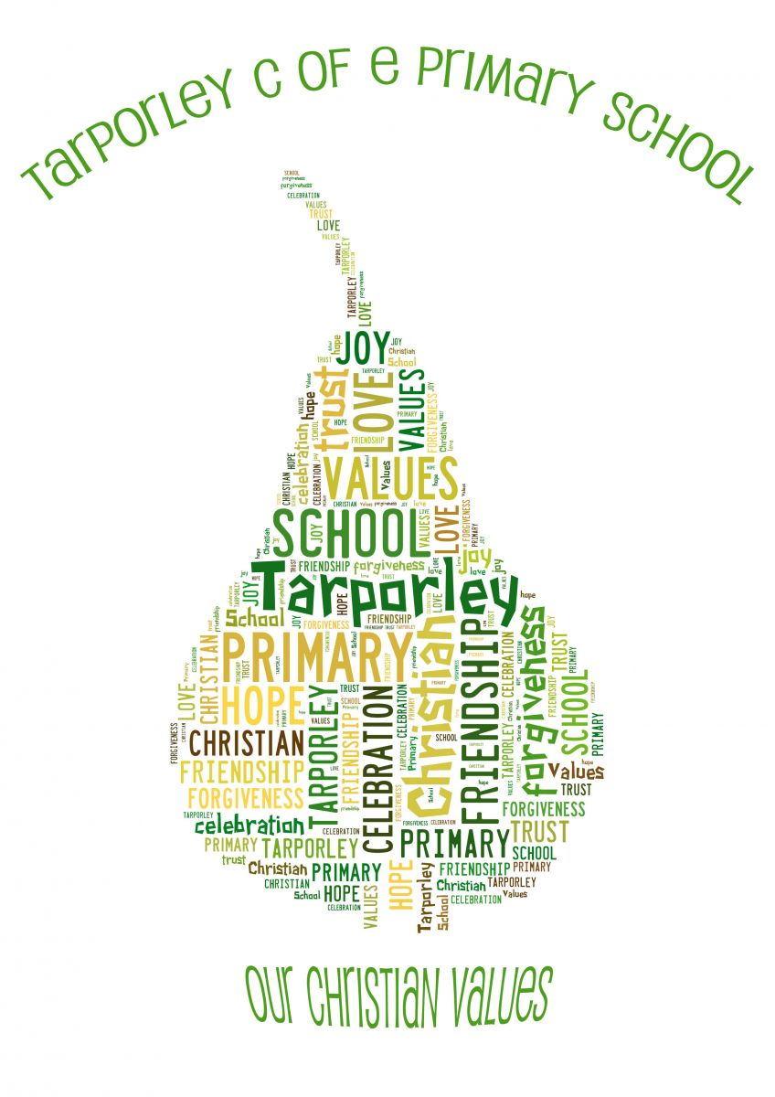
It is very important to us that the children are happy and experience the best education possible. We value strong links and a close partnership between home, church and school and recognise the importance of trust and shared responsibility in education.

Physical Education (PE) policy

Physical Education Policy

1 Overview

1.1 Physical Education (PE) contributes to the overall education of all children by helping them to lead full and valuable lives through engaging in purposeful and high-quality activity. Through a high-quality physical education programme, pupils develop physical competence and confidence and are given opportunities to be physically educated and become physically literate. PE at Tarporley CE Primary enables children to learn confidence, perseverance, team spirit, positive competitiveness and organisation. PE in our school encourages fitness, improves their strength and teaches them the rules of games. PE is an integral part of school practice and it allows all children to gain a sense of achievement, develop positive attitudes towards themselves and others whilst also enabling them to ‘Let their light shine’.

2 Funding

2.1 State funded schools receive additional PE and Sports Premium funding from the government and this is based on the number of pupils enrolled in school. This funding must be used to make additional and sustainable improvements to the quality of PE and sport that is offered at Tarporley CE.

The premium is used to:

- Develop or add to the PE and sport activities we already offer;

- Build capacity and capability within the school to ensure that improvements made are sustainable and benefit children currently in school as well as those joining the school in future years.

There are 5 key indicators that the PE and Sports premium assist with:

- The increase general health and wellbeing across the school – the engagement of all pupils in regular physical activity;
- The profile of PE and sport is raised across the school as a tool for whole-school improvement;
- Increased confidence, knowledge and skills of all staff in teaching PE and sport;
- A broader experience of a range of sports and activities offered to all pupils;
- Increased participation in competitive sport.

As part of the funding criteria, we are required to publish details on our website of how we plan to spend the premium together with a review of the impact on pupil outcomes at the end of each year. Follow the link for more details - Tarporley CE Primary School: PE & Sports Premium (including swimming competency)

3 Aims and objectives

3.1 The aims of the PE curriculum are:

- To develop competence to excel in a broad range of physical activities.
- To ensure our children are physically active for sustained periods of time.
- To engage in competitive sports and activities.
- To lead healthy, active lives.
- To swim competently, confidently and proficiently over a distance of at least 25 metres (using a range of strokes effectively).
- To perform safe self-rescue in different water-based situations.

3.2 The objectives of the PE curriculum are:

- To provide a broad, balanced and relevant curriculum that satisfies the needs of the National Curriculum and provides pupils with appropriate challenge with acceptable risk.
- To develop a whole school approach to physical development which takes pupils through progressive stages of learning and challenge, enabling them to fulfil their potential, develop competence and control in the gross and fine motor skills that pupils need to take part in PE and sport.
- To Provide pupils with opportunities to use imaginative ways to express and communicate ideas, solve problems and overcome challenges, both as individuals and as part of a team or group.
- To ensure pupils understand that PE and sport are an important part of a healthy, active lifestyle and understand the contribution physical activity has on having a healthy body and mind.
- To develop pupils’ stamina, suppleness, strength and the mental capacity (determination and resilience) to keep going.
- To develop an environment in which pupils have the confidence to get involved in PE and sport and are committed to make it a central part of their lives both in and out of school.
- To provide an out of school hours programme of activities which extends and enriches curriculum provision and provides opportunity for activities to enable pupils to make sufficient progress to access curriculum sessions with greater success.
- To provide opportunities for competition appropriate to the stage of the individual pupil’s development.
- To ensure that pupils enjoy PE and school sport and establish community links and pathways for pupils to engage in life-long participation.

The aim of physical education is to develop physical competence so that all children are able to more efficiently and safely and understand what they are doing. The outcome – physical literacy – is as important to children’s overall development as literacy and numeracy.

4 Teaching and learning style

4.1 We provide suitable learning opportunities for all children by matching the challenge of the task to the ability and experience of the child. We achieve this in a variety of ways, by:

- Lessons will be planned to provide appropriate challenge for all pupils, to extend more able and provide appropriate levels of support in order for all pupils to make progress.

- The learning environment will enable all pupils to recognise their own and others’ strengths and areas for improvement and provide them with appropriate tasks to improve and succeed.

- A variety of teaching styles will be used to engage the variety learners, providing them with the opportunity to learn from visual, auditory and kinaesthetic activities.

- Lessons will provide appropriate activities which enable pupils to develop as independent enquirers, creative thinkers, reflective learners, team workers, self-managers and effective participators.

5 Implementation of the PE Curriculum

5.1 Early Years:

Physical activity is vital in children’s all-round development, enabling them to pursue happy, healthy
and active lives. By creating games and providing opportunities for play both indoors and outdoors, adults can support children to develop their core strength, stability, balance, spatial awareness, co-ordination and agility. Gross motor skills provide the foundation for developing healthy bodies and
social and emotional well-being. Fine motor control and precision helps with hand-eye co-ordination,
which is later linked to early literacy.

Pupils should be taught to:

Gross Motor Skills
- Negotiate space and obstacles safely, with consideration for themselves and others.

- Demonstrate strength, balance and coordination when playing.

- Move energetically, such as running, jumping, dancing, hopping, skipping and climbing.

Fine Motor Skills
- Hold a pencil effectively in preparation for fluent writing – using the tripod grip in almost all
cases.

- Use a range of small tools, including scissors, paint brushes and cutlery.

- Begin to show accuracy and care when drawing.

5.2 Key Stage 1:

Pupils should develop fundamental movement skills, become increasingly competent and confident and access a broad range of opportunities to extend their agility, balance and coordination, individually and with others. They should be able to engage in competitive (both against self and against others) and co-operative physical activities, in a range of increasingly challenging situations.

Pupils should be taught to:

- master basic movements including running, jumping, throwing and catching, as well as developing balance, agility and co-ordination, and begin to apply these in a range of activities.

- participate in team games, developing simple tactics for attacking and defending.

- perform dances using simple movement patterns.

5.3 Key Stage 2:

Pupils should continue to apply and develop a broader range of skills, learning how to use them in different ways and to link them to make actions and sequences of movement. They should enjoy communicating, collaborating and competing with each other. They should develop an understanding of how to improve in different physical activities and sports and learn how to evaluate and recognise their own success.

Pupils should be taught to:

- use running, jumping, throwing and catching in isolation and in combination.

- play competitive games, modified where appropriate [for example, badminton, basketball, cricket, football, hockey, netball, rounders and tennis], and apply basic principles suitable for attacking and defending.

- develop flexibility, strength, technique, control and balance [for example, through athletics and gymnastics].

- perform dances using a range of movement patterns.

- take part in outdoor and adventurous activity challenges both individually and within a team.

- compare their performances with previous ones and demonstrate improvement to achieve their personal best.

Swimming and water safety
Pupils are taught to:

- swim competently, confidently and proficiently over a distance of at least 25 metres.

- use a range of strokes effectively.

- perform safe self-rescue in different water-based situations.
5.4 BOOKS approach – links to other curriculum areas

At Tarporley CE, we want our curriculum to have the BOOKS approach: Demonstrate BRAVERY, be OUTWARD-FACING, create memorable OPPORTUNITIES, provide KNOWLEDGE and SKILLS and nurture SPIRITUALITY.

Contribution of PE to teaching in other curriculum areas:

English
- Links between PE and English include: writing sequences, following/giving instructions, oral/peer assessments, speaking and listening, and movement within drama.

Maths
- Links between PE and Mathematics include: measurement, shape and space, sequences, number, angles, position and movement, rotation and time.

ICT
- Children use capturing and recording equipment (cameras and videos) for evaluation/ development of skills. Videos of professional/skilled athletes are also used to help develop good technique.

PSHE
- PSHE and PE links include following rules, living healthily, co-operating with others and understanding fairness and equality.

Christian Values
- Through sport children are taught the values of respect, trust, honesty, friendliness and perseverance.

Healthy Eating
- The school recognises that physical activity is just one element of healthy lifestyles and actively promotes healthy eating to help combat child obesity. These messages are shared in clubs, lessons and through cookery sessions with all age groups.

SMSC
- PE offers many opportunities that support the social development of our children. Groupings allow children to work together and give them the chance to develop respect for the abilities of other children through collaborative and co-operative work, while gaining a better understanding of themselves.

5.5 Inclusion

At our school, we teach PE to all children, whatever their ability and individual needs. This is in line with the school's curriculum policy of providing a broad and balanced education to all children. Through our PE teaching, we provide learning opportunities that enable all pupils to make good progress. We strive to meet the needs of those pupils with special educational needs, those with disabilities, those with special gifts and talents, and those learning English as an additional language, and we take all reasonable steps to achieve this. For further details see the relevant SEN, Pupil Premium and More Able policies. We recognise the fact that we have children of differing ability in all our classes. We believe that the curriculum should be accessible to all children.

5.6 Progression and Continuity

The activities in PE build upon the prior learning of the children. Whilst we give children of all abilities the opportunity to develop their skills, knowledge and understanding, we ensure continuity and progression so that there is an increasing challenge for the children as they move up through the school.

5.7 Outcomes

Planning for PE is initially set out on iPEP, with collaboration between teachers and our sport coach with S4YC. Long term plans are created, ensuring that there is full coverage of the national curriculum aims. Lesson plans are then available for teachers to access via iPEP.

High quality lessons should include:

- a statement of the learning objective
- a whole class risk assessment
- teaching the children to warm up correctly and safely
- the teaching of skills and techniques
- the application and adaptation of learnt skills in game activities
- modelling of correct technique
- use of correct and specific technical vocabulary
- performance and evaluation of each other’s work
- work which reflects the learning objective
- teaching the children to warm down correctly and safely
- teaching the impact that PE has on their bodies.

5.8 Celebration

Excellence and achievement is celebrated through:

- house points system
- performance in class sessions and acknowledgement of achievements in assembly
- participation in tournaments, including the Sandstone Partnership events
- an annual Sports Day involving all pupils
- the awarding of certificates, badges and trophies
- the school twitter page.

6 Assessment and recording

6.1 Assessment is an integral part of the teaching process. The assessment process is on-going to ensure that the lesson objectives are being achieved and that progress is being made. Both formative and summative assessment takes place in PE by teachers and sports coaches.

- Feedback to pupils about their own progress takes place in the context of the PE lesson;
- Formative assessments are made by the teacher/coach through observations made in PE lessons;
- A photographic/video record is sometimes used to document some of the children’s work.
- Physical development levels and progress are recorded by the EYFS teachers for each child.
- At the end of each unit of work, the teacher/coach complete pupil assessments in iPEP in order to update the children’s attainment and progress in that area of PE.
- These assessments are used to assist in reporting to parents and passed on to the following class teacher.
- They help inform future planning.

7 Role of the Subject Leader

7.1 Training

- Provide support and training for staff in-house, including the planning, teaching,
assessing, and evaluating of the P.E. curriculum.
- Provide up-to-date information for teachers on (online) resources in PE and new
initiatives/schemes.
- Seek further training and support from specialist teachers and coaches and via the SGO (School Games Organiser).
- Over the course of an academic year, ensure all teachers can observe/team teach with
specialist teachers, in order to make their contribution sustainable.

7.2 Curriculum

- Oversee, with support from the curriculum lead, the teaching and learning in PE in line with the Curriculum Map.
- Timetable specialist teachers and coaches (liaising with Head Teacher).
- Ensure the PE curriculum resources available to teachers are of a good standard and a quantity.
- Promote PE and Sport across the school, encouraging children’s participation and celebrating both involvement and success.

7.3 Organisation

- Register the school for the Sandstone Partnership events.
- To report on school swimming attainment annually and record this online.
- Complete Risk Assessments for sporting events.
- Organise Sports Day(s) annually.
- Report to the Head Teacher and Governors on PE.

7.4 Budgeting

- To complete the ‘Evidencing the Impact of the Primary PE and Sport Premium’ document annually (liaising with the Head Teacher).

8 Health and Safety

Safety should be paramount when planning PE activities. Children should develop their own abilities to assess risks. First aid equipment should be available and staff should know what to do and who to call for assistance in the event of an accident. Inhalers for children suffering from asthma must be readily accessible and brought to lessons. Regular checks should be made on all equipment. The curriculum manager should make frequent visual checks for wear and tear and security of major items, and all staff should be responsible for reporting to the curriculum manager when any items need replacing or repairing. Any items constituted a danger should be taken out of use immediately.
In order to minimize these risks all staff and children in PE lessons are required to take note of the following:

• All lessons are planned following a clear progression of developing skills and take into account the age, abilities and special needs of the class.
• Children should be made aware, understand and follow all safety requirements related to the use of specific equipment, appropriate clothing and the following of instructions when in a lesson.
• Children should be taught how to move and use apparatus safely under supervision of a teacher or responsible adult.
• Teaching staff should ensure equipment is safe and in a good condition and suitable to the needs and abilities of the children. Any faulty equipment should be reported to the curriculum manager who will then repair or replace the faulty equipment.
• Children should understand the safety risks involved in wearing inappropriate clothing, footwear or jewellery. Jewellery, including watches should be removed or when earrings can’t be removed, they are taped up. Pupils with medium/long hair are reminded to tie it back securely, as per school policy.
• Children should be made aware of safe practice when undertaking any PE activity (e.g. not running or jumping in front of others and stopping when asked).
• Teaching staff should ensure and expect high standards of behaviour, performance and participation in all lessons.
• Teaching staff should follow the school’s behaviour plan at all times.
• Children should be made aware of the importance of stretching in physical activity and how to use the correct technique.
• Teachers should conduct a visual risk assessment of the learning environment and PE equipment as well as the children’s clothing; particularly footwear, before proceeding with any PE lesson.
• Pupils should be responsible for their own inhalers and always have them with them. For younger children, a member of staff will ensure inhalers are on hand immediately during PE lessons.
• Pupils should warm-up and cool-down at the start/end of each session.
• New staff have an induction on how to use the school PE equipment safely.

Weather

It is encouraged that outdoor PE lessons take place in all seasons and in as many weather conditions as feasibly possible. Classes are timetabled so that at least one of their two allocated lessons per week can take place in the hall, therefore allowing the PE lesson to still go ahead even if the weather is bad. Children are encouraged to wear clothing in line with the season and weather conditions, maximising access to all lessons.

Hygiene

Pupils are taught about the body changes that occur when they exercise along with recognition of the short and long term effects of exercise on the body. Aspects of hygiene are addressed in upper KS2.

Staff dress

It is important that staff should consider their own and their pupils' safety with regard to their own personal clothing, footwear and jewellery when involved in the teaching of any PE activity.

9 Equipment and resources

The majority of the PE equipment is stored in the PE sheds outside (large metal container and wooden shed). Some smaller pieces of equipment are stored in the PE cupboard in the hall. The equipment suitability is reviewed to ensure it is appropriate to the range of ages, abilities and needs of children in order to enhance learning.

Pupils and staff are encouraged and expected to:
- Treat the resources and equipment with respect;
- Use different resources to promote and enhance learning;
- Return all resources tidily and to the correct place (staff supervision required when needed);
- Ensure all resource storage areas are kept tidy and report any faulty or unsafe equipment to the PE co-ordinator;
- Be told of any safety procedures relating to the carrying or handling of resources.

10 Monitoring and review

10.1 The PE curriculum manager is responsible for the monitoring of the implementation of this policy. The PE curriculum manager is responsible for monitoring the standard of children’s work and for the quality of teaching in line with the school’s monitoring policy. This may be through supporting colleagues in the teaching of PE, being informed about current developments in the subject, and providing a strategic lead and direction for PE in the school. The curriculum manager is responsible for monitoring the children’s progress in PE through lesson observations and assessments and by completing an annual audit and subsequently creating an action plan to give to the head. This policy document will be reviewed every twelve months to assess its value as a working document.

Signed: J Bonner Date: September 2023 Review: September 2026

