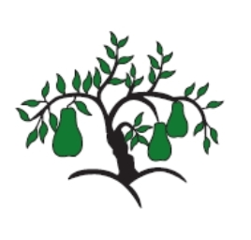 | Little Wandle - Letters and Sounds  EYFS Phonics Home Learning | 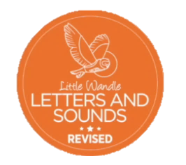
Phase 4 – Summer 2 Week 1
Focus – CVCC and CCVC words with long vowel sounds
Please support your child to practise and reinforce the phonemes and graphemes we are learning in school. More information and support can be found on the Little Wandle website - https://www.littlewandlelettersandsounds.org.uk/resources/for-parents/

We will be reading CVCC and CCVC words with long vowel sounds
toast joint burnt paint spark boast bleed growl smart groan speech bright
sport steep float train start flight
green brown gloom spoon storm broom

We will be practising tricky words. Can you spot the tricky part of the word?
we he she me be of says there when what one

Can you match the words and pictures?

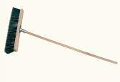

broom paint train spoon

We will be reading sentences. Can you spot any tricky words?
A bright spark burnt the toast.
Today the train was late and we missed the flight.
The dog had a growl at the storm.

