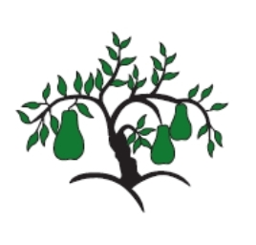 | Little Wandle - Letters and Sounds  EYFS Phonics Home Learning | 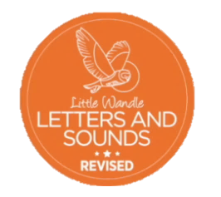
Phase 4 – Summer 1 Week 2
Focus – CVCC and CCVC words
Please support your child to practise and reinforce the phonemes and graphemes we are learning in school. More information and support can be found on the Little Wandle website - https://www.littlewandlelettersandsounds.org.uk/resources/for-parents/

We will be reading CVCC and CCVC words
champ chimp chest punch bench munch shift shelf hunt cost melt milk shrink crack smash frog smell swim drum dress plug drink bring truck

We will be practising tricky words. Can you spot the tricky part of the word?
some come love do

Can you match the words and pictures?
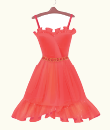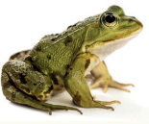

frog drum dress milk

We will be reading sentences. Can you spot any tricky words?
The chimp sits on the bench to munch a carrot.
The foxes hunt at night in the dark.
I cannot swim in the pond with the frogs.

