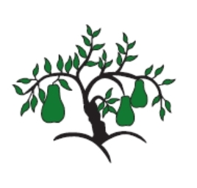 | Little Wandle - Letters and Sounds  EYFS Phonics Home Learning | 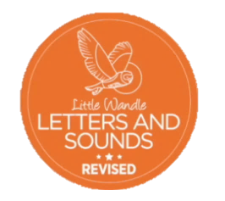
Phase 4 – Summer 1 Week 1
Focus – CVCC words with short vowels
Please support your child to practise and reinforce the phonemes and graphemes we are learning in school. More information and support can be found on the Little Wandle website - https://www.littlewandlelettersandsounds.org.uk/resources/for-parents/
We will be reading CVCC words
went help tent wind hand hump lamp jump band lump lift best gift nest soft just lost thump tenth belt sixth fact pond

We will be practising tricky words. Can you spot the tricky part of the word?
said so have like

Can you match the words and pictures?
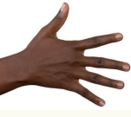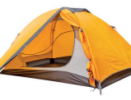

nest tent lamp hand

We will be reading sentences. Can you spot any tricky words?
Help the farmer put up the tent.
Lift up the lamp so I can see the lump.
The best gift is the big box.
I have lost my belt by the pond.

