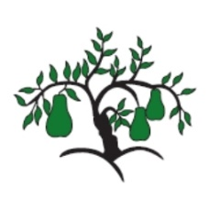 | Tarporley CE – Little Wandle  EYFS Phonics Home Learning | 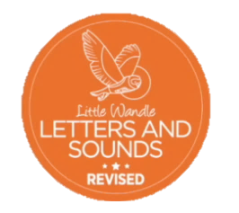
Phase 3 – Spring 2 Week 2
Focus – double letters/ longer words
Please support your child to practise and reinforce the phonemes and graphemes we are learning in school. More information and support can be found on the Little Wandle website - https://www.littlewandlelettersandsounds.org.uk/resources/for-parents/
Phonemes we have been focusing on this week in school –
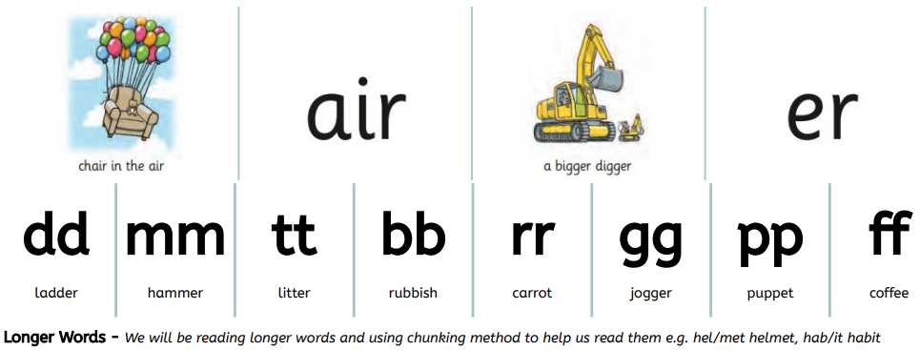

We have been reading and writing longer words. Can you spot this weeks phonemes?
bigger chair fair rubber shimmer butter supper chatter muffin mutter buzzer cannot laptop seven fantastic comic

We have been reading sentences. Can you spot any tricky words?
This pink chair is bigger than the red chair.
We feed the chicken and rabbit supper.

We have been practising tricky words. Can you spot the tricky part of the word?
and go no of

